User Manual

YH-9801S

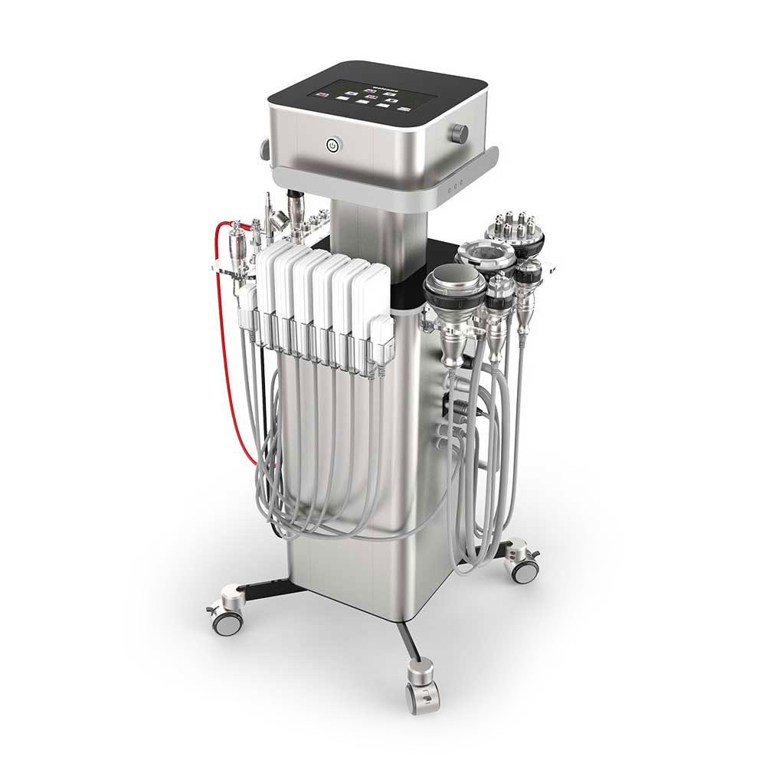

Preface

Dear Users,

We’re pleased to present to you our latest integrated beauty machine YH-9801S, which is so versatile with various kinds of handpieces for face and body treatments. It is a professional beauty machine, which needs to be handled by professionals with proper training. Any improper use will result in adverse outcomes. Therefore, we advise people to read this manual thoroughly and follow the instructions strictly before operation.

We believe our quality product will bring in good returns on your end. Also, you can count on our worry-free after-sales service.

Thank you!

Table of Contents
Preface
Part I
Introduction
1. Advantages
2. Working Principles
3. Skin Cleansing & Rejuvenation
4. Skin Firming and Lifting
5. Eye Anti-wrinkle
6. Neck Care
7. Body Management
(1). Waist & Abdomen Shaping
(2). Arm Shaping
(3). Back Shaping
(4). Hip Shaping
(5). Leg Shaping
Part II

1. Working Interfaces
2. Technical Specifications
3. Dos and Don’ts
4. Troubleshooting & Solutions
5. FAQs
6. Packing List
7. Simplified Treatment Steps
8. Operational Diagrams

Part I

Introduction
This machine is equipped with as many as 10 handpieces, which can offer more professional and targeted skin treatments for different skin types and skin problems. Those technologies adopted in this machine are currently widely popular in beauty industry. After constant testings and improvements, this machine is developed with several technologies combined as one to better suit users’ needs. So, this machine is an effective replacement of most treatments in beauty salons. Moreover, it is convenient and easy to operate. It solves both skin and body management problems for beauty-seekers. This equipment requires no injection, no medication, and no operation, for which it has no side effects. It is used externally during the whole process and has an immediate effect. In order to achieve satisfactory treatment results, please read through the following content of this user manual.

Advantages
1. Multifunctional beauty machine for facial and body care.
2. There are several handpieces for treatment. You can use corresponding one based on different needs and different treatment areas.
3. One machine has several functions, freeing you of making a choice for its being easy and convenient to use.
4. Advanced integrated cavitation 2.0 technology is adopted, offering users more comfortable fat removal experience.
5. Intelligent 3D RF technology features automatic energy adjustment based on skin temperature.
6. The BIO micro electric currents can help with skin firming and anti-ageing.
7. The lipo laser treatment, as an ancillary approach to reducing fat, can provide consolidating effects.
8. Humanized wheeled design allows you to use this machine any other place.
9. It is suitable for professional licensed beauty salons.
10. Colour touch screen is convenient to use, giving users great experience.
11. It is painless and non-invasive treatment process. Once the treatment is over, customer can go back home and there is no downtime, which means it will not affect customer’s life and work.
12. No consumption, low cost and quick returns.
13.Unevenness, bleeding, and swelling will not appear after treatment.

Working Principles
- Spray
It uses high pressure to make oxygen and water smaller than 80 μm work on skin in the form of spray, which can lead the molecules of water and oxygen into deep skin to accelerate nutrient absorption. It directly and quickly provides nutrients for skin by making them penetrate through pores and skin crevice from epidermis to deep skin through high pressure to accelerate cell regeneration and remove deep waste. Moreover, the oxygen and nutrients can stimulate the regeneration of fiber tissue in dermis and accelerate metabolism to deliver the results of hydrating & rejuvenating skin and removing skin yellowness.

Physical effects:
Putting the advanced technology of Pressure Swing Adsorption (PSA) into practice, the 8-kilogram built-in high-pressure oxygen pump can quickly separate highly pure oxygen from air and then transport the mixture of 80% pure oxygen and 0.9% water molecules to deep cells to replace waste and toxin, by which it can promote metabolism to make skin have cleanliness, clarity and glow.

- Dermabrasion
It uses a special tube, on the top of which is inlaid fine diamond particles of different thickness. By rubbing back and forth with the vacuum suction, the shallow layer of epidermis is worn off, which is a non-invasive physical skin abrasion. By abrading dead cells on the surface of the skin, the regenerating ability and skin texture are improved. After treatment, the fine wrinkles will be reduced, the skin will become smooth, and the skin will be rejuvenated. Meanwhile, it will have the effect of lifting skin in conjunction with hand operation.

Physical effects:
The vacuum suction technology is adopted to reduce the internal air pressure, which can effectively remove corneum, and suck out the pore waste such as blackhead and excess grease. In this way, it can realize free substance circulation of skin. Generally, it has the effect of dredging pores, improving pore size and brightening skin tone.

- Eye RF
Radiofrequency waves penetrate your skin and then produce energy utilizing electrical resistance generated by the skin, raising your underlying skin's temperature. By stimulating collagen production, the procedure firms the skin around your eyes and removes eye bags and dark circles. It can also relieve red spots on your eyes and reduce fine lines.

- Face RF
Radiofrequency waves penetrate your skin and then produce energy utilizing electrical resistance generated by the skin, raising your underlying skin's temperature. The process further stimulates the production of collagen, which helps lift and firm saggy and loose facial skin and produce collagen continuously.

- Body RF
The handpiece uses radiofrequency heating to generate radiofrequency waves in specific depths under the skin. The waves penetrate the epidermis and then act on the dermis to heat tissue and promote catabolism of subcutaneous fat. Meanwhile, it stimulates the production and restructuring of collagen and elastic fibers. As collagen in the dermis keeps producing and realigning, the treatment lifts and tightens your loose skin.

- FACE VACUUM & RF
The handpiece uses vacuums to massage your skin and muscle, which boosts the mobility of fluid in cells and cells' movement. Therefore, cells can be activated, improving skin elasticity and accelerating the microvessels' blood circulation. Additionally, vacuums can stimulate the sympathetic nervous system of the skin's surface and deep layer and lower skin sensitivity. The suction and release of vacuum improves the capillary system, tightens saggy and loose facial skin, and lifts and firms your skin.

Advantages: This equipment has a unique radiofrequency (RF) handpiece. And its RF handpiece and vacuum handpiece are separated and complementary. Therefore, it works more efficiently and rapidly than the standard RF handpiece. The handpiece comes with red light, which diminishes inflammation and kills bacteria, activates cells, and increases skin elasticity.

- Body Vacuum & RF
RF: Radiofrequency waves penetrate your skin and produce energy utilizing electrical resistance generated by the skin, raising your underlying skin's temperature. The process heats tissue rapidly and continuously and stimulates collagen production. Thus, it lifts, firms, and refines your skin. The match of the two promotes skin tightening and prevents loose skin while blasting your fat.

Vacuum: The handpiece uses vacuums to massage your skin and muscle, which boosts the mobility of fluid in cells and cells' movement. Therefore, cells can be activated, improving skin elasticity. It also accelerates the microvessels' blood circulation, removing extra toxins from your body via the lymphatic system's circulation. Therefore, it can lower the chances of adverse situations to your body parts, such as pigmentation disorder, congestion, etc. The kneading effect generated by vacuums can increase the movement of your skin and muscle. That reduces areolar tissue and improves skin elasticity, completing fat loss and body sculpting simultaneously. Besides, vacuums can stimulate the sympathetic nervous system of the skin's surface and deep layer and lower skin sensitivity. The suction and release of vacuum improves the capillary system, promotes flow between deeper veins and lymph gland networks, strengthens blood vessels, and relieves varicosity.

Advantage: It breaks through the vacuum's previous working mode featured by singleness and simpleness. Using different modes for different body parts can sculpt your body more efficiently and better and cause no harm. This equipment has a unique radiofrequency (RF) handpiece. And its RF handpiece and vacuum handpiece are separated and complementary. The handpiece massages your skin and promotes metabolism while heating the deep skin layer, yielding twice the result with half the effort.

The Physical Effect of Vacuum
Skin Layer
The suction and release of vacuum:
- Improve mobility among cells to increase cell movement, curing blood-stasis-related diseases.
- Remove moisture from the lymph gland and veins.
Effect: Discharge excess moisture from fibrous tissue.

Vascular Layer
The suction and release of vacuum:
- Boost microvessels' blood circulation on top of the capillary system and promote flow between deeper veins and lymph gland networks.
- Remove extra toxins from your body.
- Strengthen blood vessels and relieve varicosity.

Fibrous Layer
The suction and release of vacuum:
- Promote the combination of two effects generated in different tissues (including skin, muscle tissue, etc.).
- Repair cell tissue and enhance activity among cells.
- Boost and restore skin elasticity and resist skin stretch.
- The production of ossein helps renew skin and restore elasticity.
- Enhance skin's oxygen supply capacity and increase carbon dioxide consumption.
Effect: Break up tough bands that cause cellulite, making it more elastic to shape the body.

Nervous Layer
The suction and release of vacuum:
- Stimulate the sympathetic nervous system of the skin's surface and deep layer.
- Lower skin sensitivity.
- Restore skin elasticity and resist tissue fibrosis.
Effect: Repair and lower skin sensitivity.

- BIO
It outputs bioelectric currents that simulate the human body, which enters muscle cells after penetrating your skin. The currents stimulate intracellular adenosine triphosphate (ATP), restoring the cells' regular operation and functions and supplying energy to your muscle and body. Increasing the cell's permeability, 30% to 40% higher than usual, helps the body absorb nutrition and moisture better and improves oxygen content in the blood. Meanwhile, it expels wastes, toxins, and stranded liquids as soon as possible. Stimulating muscle fiber synthesis, 68% higher than usual, makes the skin moisturized, soft, firm, and shiny. Raising the collagen's synthesis level by 73% can lessen wrinkles and make skin softer, elastic, and glossy.

- 40K
The principle of ultrasonic wave is used to make human adipose cells take a strong impact and produce friction movement among them after strong sound waves enter into the human body, which can effectively consume heat and water of cells and shrink adipose cells. In addition, when the sound wave vibrates, it can produce a strong impact on cells. And then the adipose cells will burst instantly, and they will be reduced so as to achieve the effect of fat removal.

Ultrasonic Cavitation: Tens of thousands of tiny bubbles, namely cavitation bubbles, are produced by vibration of liquid. These bubbles grow in the negative pressure region formed by the longitudinal transmission of ultrasound, which will close rapidly in the positive pressure region to be compressed and stretched under alternating positive and negative pressures. When the bubbles burst, there will be huge instantaneous pressure of up to tens of MPa to hundreds of MPa, and strong vibration and noise will be produced.

Advantages: It only aims for low-density adipose tissue for its specific frequency and protects high-density tissue such as vascular and nerve tissue.

- Lipo Laser
It uses a red laser, a visible spectrum. The laser has mighty penetrating power, which can activate and repair fat cells. When lasers penetrate the fat layer, they heat subcutaneous fat and dissolve them. The treatment is safe and painless and has no side effects. It sends low-level laser energy to fat cells, decomposing triglycerides deposited in the fat layer into free fatty acids and glycerol, which are released through a cell membrane's passage. Fatty acids and glycerol are transported to tissue in the body that produces metabolic energy. When the body needs to use the stored energy reserves, the fatty acid release is a natural response. Therefore, it will not cause the body to produce an unnatural reaction and affect or damage the surrounding structures, such as the skin, blood vessels, and peripheral nerves. After therapy, the free fatty acids inside the body will be removed through intact metabolism.

Biological effect:
The laser heats fat cells in the targeted zone to decompose them. Fat deposition is absorbed and discharged via our body's natural metabolism in a short time. The laser seals tiny blood vessels, reducing bruises and channeling heat into the treated area. The action also stimulates collagen production to tighten and smooth your skin.

The low-energy laser (biostimulation) goes directly to the deep fat layer. It utilizes the energy of the proper level to stimulate biological cells and induces or strengthen a series of physiological reactions, such as promoting local blood circulation, regulating cell function, enhancing immune function, and facilitating cell metabolism. It can tighten skin, remove wrinkles, reduce fat, and shape the body simultaneously. The laser has mighty penetrating power, which can activate and repair fat cells. When lasers penetrate the fat layer, they heat subcutaneous fat and dissolve them. The treatment is safe and painless and has no side effects.

3. Skin Cleansing & Rejuvenation
(1). Effects
1. Supply water and nutrients for deep skin layer.
2. Remove corneum and balance moisture and grease.
3. Remove blackheads and relieve the symptom of strawberry nose.
4. Contract pores, and whiten and rejuvenate skin.
5. Promote blood circulation and increase skin elasticity.
6. Relieve the symptom of bloodshot eyes.

(2). Applicable Range
1. Those with imbalance of moisture and grease.
2. Those who have dry skin, peeling skin and so on.
3. Those who have clogged pores or large pores.
4. Those who have dark and dull skin.
5. Those who have low skin metabolism and poor skin absorption.
6. Those who have overly frequent grease secretion.

(3). Inapplicable Range
1. Those who have just undergone plastic surgery with prostheses and metal materials, etc., implanted at the target area in recent three months
2. Those who have experience in injection products recently, such as hyaluronic acid, or those who have mesotherapy, or wrinkle removal treatments in recent three months.
3. Those who suffer from heart diseases or have pacemakers in their body. Those suffer from epilepsy, severe diabetes, hyperthyroidism, malignant tumors, haemophilia and haemorrhage.
4. Those who are in allergic period or whose skin are sensitive to metals and electric currents .
5. Those who have lesions on skin or are on the road to recovery from operation.
6. Those who are of advanced years.
7. Those who are in menstruation, pregnancy or lactation.
8. Those who have skin diseases and infectious diseases.
9. Those who have unrealistic expectations about the effect.

(4). Dos and Don’ts after Operation
1. Do not wash your face with overheated water for three days (you can wash your face with warm or cold water).
2. Strengthen hydration, moisturizing and avoid sunburn.
3. Do not go for hot springs, saunas, violent exercise, etc., for three days.
4. It is recommended to apply the mask at least three times a week.
5. Avoid eating spicy and greasy food, avoid staying up late, smoking and drinking, and eat more fruits and vegetables and food with less grease.
6. Avoid those food which leads to high blood pressure, high cholesterol and high blood sugar).

4. Skin Firming & Lifting

(1). Effects
- Firm face and enable the deep introduction of nutrients.
2. Increase skin elasticity and smoothness
3. Moisturize the skin and increase the absorption rate of the skin.
4. Accelerate blood circulation and metabolism.
5. Relieve the symptoms of double chin and tighten skin.
6. Stimulate collagen proliferation and delay aging

(2). Applicable Range
1. Those whose faces are dark and dull.
2. Those whose skin is flabby and sagging.
3. Those who have fine lines, nasolabial folds, wrinkles at eye corners.
4. Those whose face contours are not clear.
5. Those who have rough skin and large pores.
6. Those who work for a long time in the office and are exposed to ultraviolet rays.
7. Those who have sagging skin, edema or puffiness after giving birth

(3). Inapplicable Range
1. Those who have just undergone plastic surgery with prostheses and metal materials, etc., implanted at the operation area.
2. Those who have experience in injection products recently, such as hyaluronic acid, or those who have mesotherapy, wrinkle removal, or plastic surgery.
3. Those who have hypertension, heart disease, diabetes, severe hyperthyroidism, malignant tumor, etc.
4. Those who are in allergic period and have severely sensitive skin and metal allergies.
5. Those who have trauma or wound on the skin.
6. Those who are of advanced years.
7. Those who are in menstruation, pregnancy, lactation, surgical recovery.
8. Those who have skin diseases and infectious diseases.
9. Those who have unrealistic illusions about the effect.

(4). Dos and Don’ts after Operation
1. Do not wash your face with overheated water for three days (you can wash your face with warm or cold water).
2. Strengthen hydration, moisturizing and avoid sunburn.
3. Do not go for hot springs, saunas, violent exercise, etc., for three days.
4. It is recommended to apply the mask at least three times a week.
5. Avoid eating spicy and greasy food, avoid staying up late, smoking and drinking, and eat more fruits and vegetables and food with less grease.
6. Avoid those food which leads to high blood pressure, high cholesterol and high blood sugar).

- Eye Anti-wrinkle
(1). Effects
1. Relieve eye fatigue, dark circles, eye bags and edema.
2. Reduce lines around eyes and crow's feet.
3. Reduce dark spots and accelerate blood circulation.
4. Accelerate metabolism and prevent pigmentation.
5. Supplement eyes with nutrition and moisturize skin.
6. Firm and soften skin, lift the corners of the eyes.
7. Accelerate blood circulation around eyes and help skin absorb nutrients efficiently.

(2). Applicable Range
1. Those with wrinkles, fine lines, bags and dark circles around the eyes.
2. Those with dry skin, dry lines and dynamic wrinkles.
3. Those with eyes prone to fatigue and dryness.
4. Those who frequently face computer screens and mobile phones.
5. Those who often stay up late and have dark circles.
6. Those who often stay in a dry or hot environment.

(3). Inapplicable Range
1. Those who had just undergone plastic surgery.
2. Those who have hypertension, heart disease, diabetes, severe hyperthyroidism and malignant tumors.
3. Those who are having an allergic reaction and have severe sensitive skin or are allergic to metals.
4. Those who have skin lesions.
5. Those who are of advanced years.
6. Those who are pregnant or convalescents.
7. Those who have skin diseases and contagious diseases.
8. Those who are sensitive to electric currents

(4). Do’s and Don’ts after Operation
1. Avoid excessive exposure to the sun. Suncream is encouraged to use.
2. After operation, the treated area is relatively dry and so being hydrated and protection against sunburn are encouraged.
3. Within 1-3 days after operation, it is better not to use alcohol, AHA or other exfoliating products.
4. Avoid facial washing with overheated water, taking a sauna, going for hot springs or other violent exercise within 7 days after operation.
5. Moisturizers and eye masks are encouraged to use. It will be preferable to use eye masks 3 times or more a week.

- Neck Care
(1). Effects
- Reduce the flabbiness, roughness and dullness of the neck skin.
- Firm skin and increase skin elasticity.
- Remove double chin.
- Accelerate lymph detox and improve facial skin.
- Prevent neck and lymph diseases.

(2). Applicable Range
- Those with rough and dull skin on the neck.
- Those with lymphatic blocking
- Those with sagging and inelastic neck skin.
- Those who often bow their heads
- Those who are not satisfied with their neck tone.

(3). Inapplicable Range
1. Those who have just undergone plastic surgery.
2. Those with hypertension, heart disease, diabetes, severe hyperthyroidism and malignant tumors.
3. Those who are having an allergic reaction, or people with severe sensitive skin.
4. Those with skin trauma or wound.
5. Those who are of advanced years.
6. Those who are pregnant or convalescents.
7. Those with skin disease and other contagious diseases.

(4). Dos and Don’ts after Operation
1. Avoid sunburn. Keep the neck warm.
2. After operation, the treated area is relatively dry, moisturizing and sun protection is encouraged.
3. Within 1-3 days after operation, it is better not to use alcohol, AHA or other exfoliating products.
4. Avoid facial washing with overheated water, taking a sauna, go for hot springs or violent exercise within 7 days after operation.
5. Moisturizing and mask for the neck is encouraged, Use masks at least 3 times a week. Essence or neck cream is encouraged.
6. Avoid bowing head for a long time.

7. Body Management
(1). Waist & Abdomen Shaping
Effects
- Relieve cold hands and cold feet, cold womb or cold body of women.
2. Tighten the skin on the waist and abdomen.
3. Reduce lumbar and abdominal fat.
4. Tighten skin, relieve stretch marks, obesity lines and increase skin elasticity.
5. Accelerate metabolism, relieve constipation and improve intestinal peristalsis.

Applicable Range
1. Those with cold feet, cold hands, cold womb and cold body.
2. Those with lumbar and abdominal fat or who have sagging skin after birth.
3. Those who often sit for a long time or have unsatisfactory waistlines.
4. Those with stretch marks.
5. Those with constipation or obstruction of abdominal meridians.

Inapplicable Range
1. Those with “3 Hs” (hypertension, hyperglycemia, hyperlipidemia) and who have heart disease.
2. Those in pregnancy, menstruation or lactation.
3. Those whose incisions are healing or who are on the road to recovery.
4. Those with epilepsy and severe diabetes and hyperthyroidism.
5. Those with malignant tumors, hemophilia or severe bleeding.
6. Those with skin diseases and infectious diseases.
7. Those with severe gynecological diseases.
8. Those whose gynecological diseases are being treated.

Dos and Don’ts after Operation
- Avoid crop top or anything exposing waist and abdomen as well as cold and windy environment.
2. Avoid binge eating or drinking. No alcohol, no spicy and greasy food. Staying up late should be avoided. Drink warm water.
3. Keep abdomen warm. Take a bath after 4-6 hours.
4. Steam sauna, hot spring or strenuous exercise should be avoided within 7 days after operation.
5. Before going to bed at night, you can rub your abdomen clockwise with your hands, so as to help with metabolism and weight loss.

(2). Arm Shaping
Effects
- Stimulate collagen growth in the bottom of the skin to shape and firm it.
- Improve sagging skin.
- Improve flabby arms and thick arms.
- Soothe and firm sagging skin.
- Tighten skin.
- Accelerate blood circulation and dredge meridians and collaterals.

Applicable Range
1. Those with thick arms and want to look better in clothes.
2. Those with flabby arms.
3. Those with sagging arm skin.
4. Those whose arms are prone to pain and numbness.
5. Those who often hold baby or children

Inapplicable Range
1. Those who have just had plastic surgery.
2. Those with hypertension, heart disease, diabetes, severe hyperthyroidism, malignant tumor, etc.
3. Those who are during allergic period and has severely sensitive skin.
4. Those with skin trauma or cut.
5. Those who are of advanced years.
6. Those who are pregnant and who are recovering from surgery.
7. Those with skin diseases and infectious diseases.

Dos and Don’ts after Operation
1. Keep warm after operation. Do not eat cold food.
2. Take shower in 4-6 hours.
3. Drink plenty of warm water to stay hydrated.
4. Do not eat and drink too much or stay up late.
5. Avoid sauna, hot spring or strenuous exercise within one week after operation.

(3). Back Shaping

Effects
1. Relieve shoulder and back soreness and improve the lump on back of the neck.
2. Dredge channels and collaterals and improve channels and collaterals blocking.
3. Increase blood circulation and metabolism.
4. Improve blood supply to the head and sleep.
5. Regulate the functions of viscera and strengthen the body.
6. Firm skin and prevent skin from sagging.
7. Reduce excess fat on the back and shape back.

Applicable Range
- Those with sore shoulders and backs and stiff necks.
- Those who suffer from insomnia, dream a lot or have a worse memory.
- Those who are prone to fatigue, drowsiness and poor circulation of qi and blood.
- Those with thick back and want to look better in clothes.
- Those who have a lump on the back of the neck.

Inapplicable Range
- Those with metal implants in the body, such as stents and pacemakers, are allergic to metal.
- Those are during pregnancy, menstruation and lactation.
- Those whose surgical wound is healing or convalescence
- Those who has “three Hs”, heart disease, epilepsy and severe diabetes and hyperthyroidism.
- Those with malignant tumor and hemophilia or severe bleeding.
- Those with skin diseases and infectious diseases.
- Those who are too weak.
- Those who are drunk, thirsty, overworked, on a full or empty stomach.

Dos and Don’ts after Operation
- Keep warm, avoid cold air and drink plenty of hot water.
- Take shower in 4-6 hours after operation.
- Avoid staying up late, drinking and overeating.
- Avoid raw, cold and spicy foods and get enough sleep.
- Avoid shoulder-baring and backless clothes

(4). Hip Shaping
Hip is located in the middle of human body and are the key hub of qi and blood circulation of meridians. It is the main switch of six meridians and also the bridge connecting the qi and blood circulation of upper and lower parts of human body, which plays an important role in building S-shaped curve and promote female attractiveness.

Effects
- Improve blood circulation and speed up metabolism.
- Improve menstrual pain, irregular menstruation, abnormal leucorrhea and other female diseases.
- Improve sleep quality, improve female sexual function and tighten the vagina.
- Activate the warm nest function, stimulate the secretion of glands, and increase the feelings between husband and wife.
- Make complexion ruddy, fade color spots and return to young state.
- Shape hips, improve sagging and outward expansion of hips, tighten skin and increase elasticity.

Applicable Range
- Those with saggy hips and fat accumulation.
- Those with stretch marks induced by obesity and obesity.
- Those whose butt shape is not good-looking, flat and soft outward expansion.
- Those with cold and cool hips with low hip temperature.
- Those with cold womb, dysmenorrhea, irregular menstruation, gynecological inflammation and other problems.
- Those with decreased estrogen levels and poor sex lives.

Inapplicable Range
- Those who are in menstruation, pregnancy, lactation and operation recovery.
- Those with hypertension, heart disease, diabetes, severe thyroid gland, malignant tumor, etc.
- Those with skin diseases, patients with infectious diseases and skin sensitive period.
- Those with wounds during recovery from surgery.
- Those with allergic and severely sensitive skin.
- Those who have just had liposuction.
- Those who are of advanced years.

Dos and Don’ts after Operation
- Keep hips warm and avoid wearing miniskirts and shorts.
- Take Shower in 4-6 hours after operation.
- Drink plenty of hot water to avoid cold air.
- Avoid staying up late, drinking and overeating.
- Avoid eating raw, cold and spicy foods and get enough sleep.
- Sauna, hot spring or strenuous exercise should be avoided within 7 days after operation.

(5). Leg Shaping
Effects
- Tighten skin and prevent sagging.
- Stimulate collagen regeneration and improve fat lines.
- Increase leg circulation and detoxification, metabolism.
- Promote blood circulation and remove blood stasis, dredge channels and collaterals, and prevent varicose veins.
- Tighten excessive protruding fat on legs and get rid of fat on thick thighs.

Applicable Range
- Those with poor circulation of lower limbs, edema and obese people.
- Those who have low immunity and feel discomfort and pain all over the body are prone to colds.
- Those with constipation and has coarse, flabby skin.
- Those whose channels and collaterals of the legs are blocked, and the proportion of the legs is poor.

Inapplicable Range
- Those who are in menstruation, pregnancy or lactation.
- Those with hypertension, heart disease, diabetes, severe hyperthyroidism, malignant tumor, etc.
- Those with skin diseases or infectious diseases.
- Those who have incisions on their bodies.
- Patients with severe varicose veins and tumors.
- Those who are having allergic reactions or who have severely sensitive skin.
- People who have just had liposuction.
- Those who are of advanced years.
- Pregnant women or who are on the road to recovery.

Dos and Don’ts after Operation
- Keep warm after operation. Do not eat cold food.
2. Take shower in 4-6 hours later.
3. Drink more warm water to keep hydrated and speed up metabolism.
4. Do not eat and drink too much or stay up late.
5. Avoid sauna, hot spring or strenuous exercise for 7 days after operation.
6. Wear pants after operation. Avoid wearing miniskirts and shorts.

Part II
- Working Interface
After making sure all are connected properly, the loading interface below will appear after the power switch is pressed.
After that, function interface will appear.
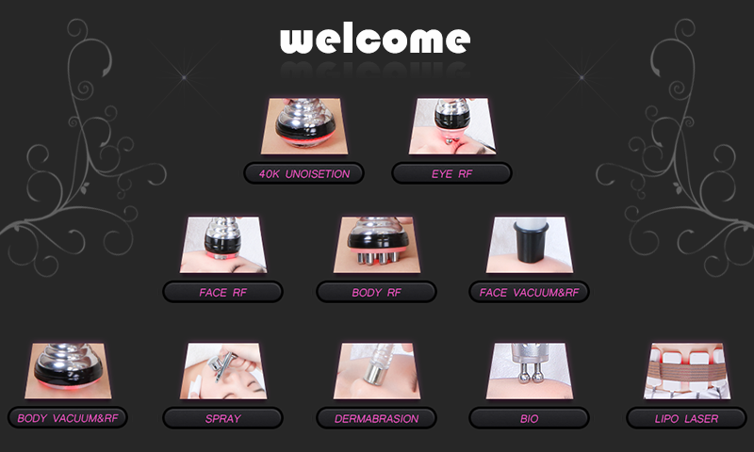
- Functions
start/stop button
home button (go to function interface
reset button (the parameter settings will go to default status)
working time (range: 00:00-60:00)
button for decreasing time
button for increasing time
buttons for adjusting energy level
button for decreasing energy level
button for increasing energy level
Energy level display (range: 0%-100%, 30%-70% is recommended.)
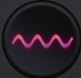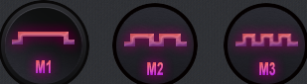working modes
button for turning on the lights of handpieces.
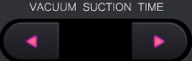buttons for adjusting suction time
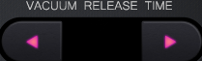buttons for adjusting release time
- Detailed Operation of 40K UNOISETION
choose 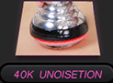 to enter the following interface
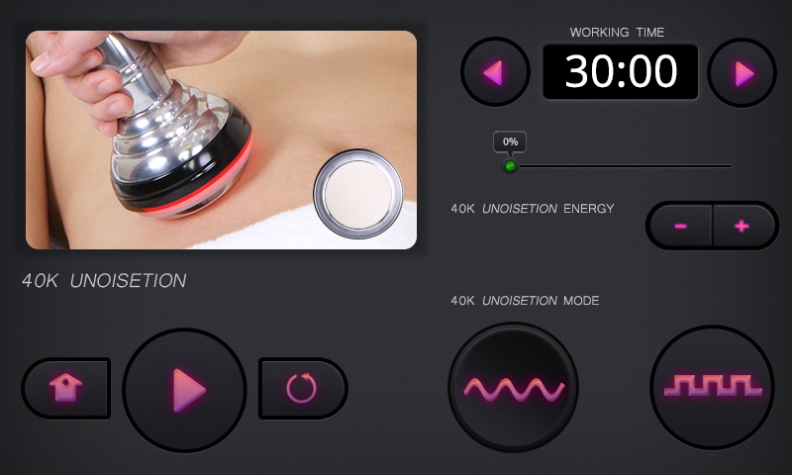
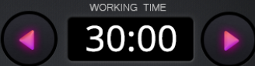buttons for adjusting working time
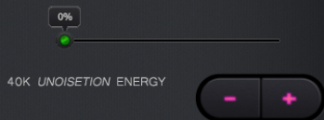buttons for adjusting energy level.
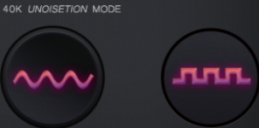two working modes
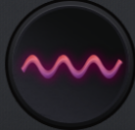Constant working mode (suitable for those who has thick fat accumulation and high adaptability)
Discontinuous working mode (suitable for those who has sensitive skin and take the treatment for the first time.)
After setting time, energy and mode, press to start the treatment.
- Detailed Operation of EYE RF
choose 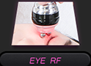 to enter the following interface
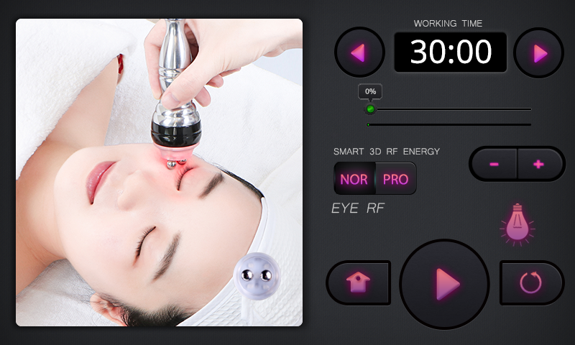
buttons for adjusting working time
energy level
buttons for adjusting energy level
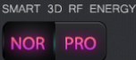two working modes
After pressing start button, the energy of handpiece directly reaches preset level.
After the start button is pressed and handpiece touches skin, the energy of handpiece slowly reaches preset level.
After pressing this button, the lights of the handpiece will be turned on no matter in NOR mode or PRO mode. Those lights can help relieve inflammation, kill bacteria and lower skin’s sensitivity.
After setting time, energy, and mode, press to start the treatment. If you want the lights of the handpiece to be turned on, just press .

4. Detailed Operation of FACE RF
choose 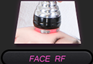to enter the following interface
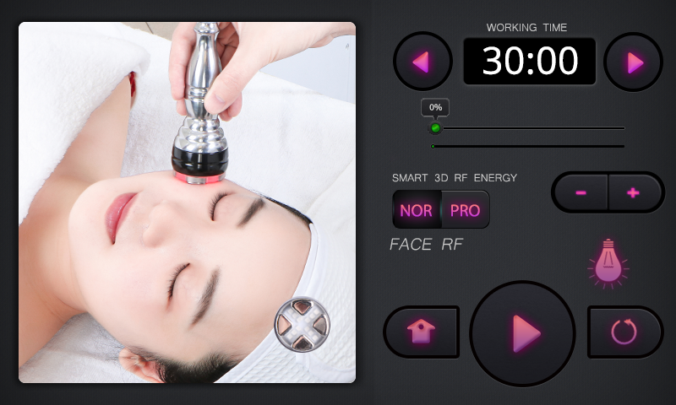
buttons for adjusting working time
energy level display
buttons for adjusting energy level
two working modes
After pressing start button, the energy of handpiece directly reaches preset level.
After the start button is pressed and handpiece touches skin, the energy of handpiece slowly reaches preset level.
After pressing this button, the lights of the handpiece will be turned on no matter in NOR mode or PRO mode. Those lights can help relieve inflammation, kill bacteria and lower skin’s sensitivity.
After setting time, energy, and mode, press to start the treatment. If you want the lights of the handpiece to be turned on, just press .

5. Detailed operation of BODY RF
choose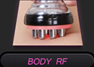to enter the following interface
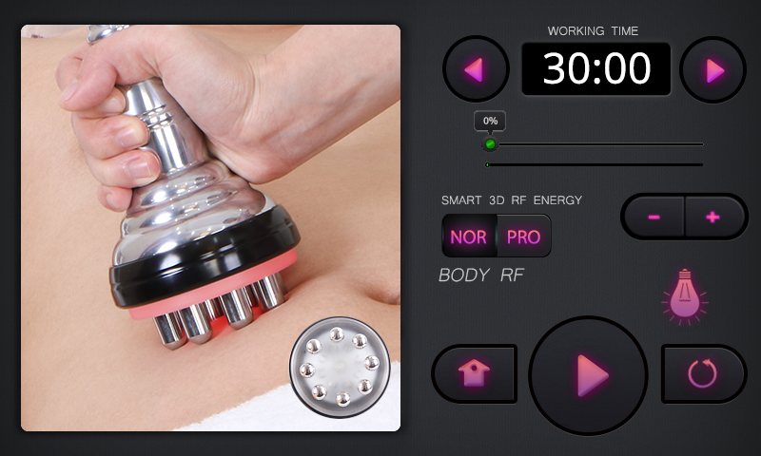
buttons for adjusting working time
energy level display
buttons for adjusting energy level
two working modes
After pressing start button, the energy of handpiece directly reaches preset level.
After the start button is pressed and handpiece touches skin, the energy of handpiece slowly reaches preset level.
After pressing this button, the lights of the handpiece will be turned on no matter in NOR mode or PRO mode. Those lights can help relieve inflammation, kill bacteria and lower skin’s sensitivity.
After setting time, energy, and mode, press to start the treatment. If you want the lights on the handpiece to be turned on, just press .

6. Detailed Operation of FACE VACUUM&RF
choose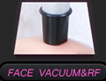to enter the following interface
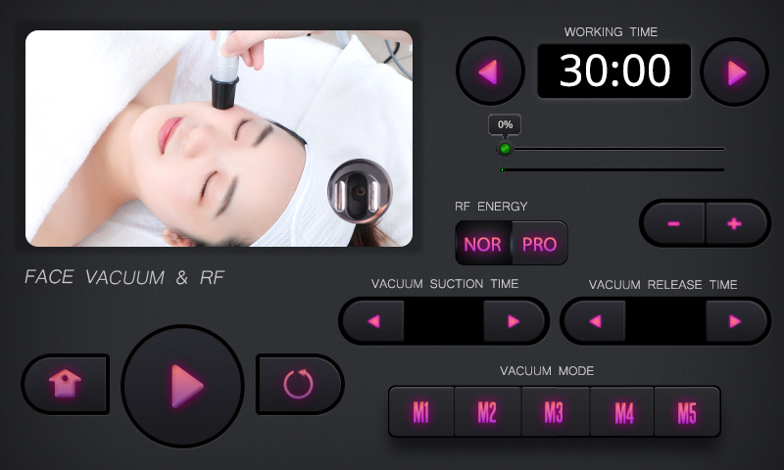
buttons for adjusting working time
energy level display
buttons for adjusting energy level
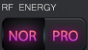two working modes for RF function
After pressing start button, the energy of handpiece directly reaches preset level.
After the start button is pressed and handpiece touches skin, the energy of handpiece slowly reaches preset level.
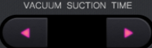suction time display and adjustment
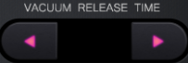release time display and adjustment
Only when suction time is longer than release time can the handpiece work properly. And when the release time is not zero, the handpiece is at Suction & Release status, which is suitable for first-time users. And when release time is zero, the handpiece is at Constant Suction status, which is suitable for those who want to unblock meridians and take cupping therapy.
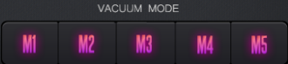five vacuum modes
M1：constant suction
M2—M5: Suction & Release, the frequency of release gradually increases from M2 to M5.
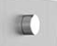Knob for adjusting suction level. Turning it clockwise is to increase suction and turning it anticlockwise is to decrease suction.
After setting time, energy level, RF mode, and suction time & release time, pressto start the treatment. Adjusting suction level based on individual endurance.

7. Detailed Operation of BODY VACUUM&RF
choose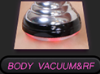to enter the following interface

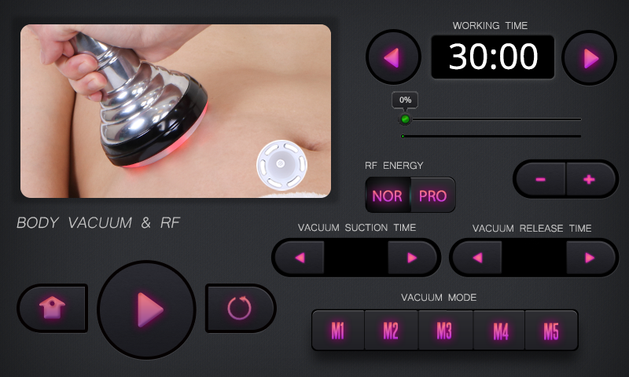
Buttons for adjusting working time
energy level display
buttons for adjusting energy level
two working modes
After pressing start button, the energy of handpiece directly reaches preset level.
After the start button is pressed and handpiece touches skin, the energy of handpiece slowly reaches preset level.
suction time adjustment
release time adjustment
Only when suction time is longer than release time can the handpiece work properly. And when the release time is not zero, the handpiece is at Suction & Release status, which is suitable for first-time users. And when release time is zero, the handpiece is at Constant Suction status, which is suitable for those who want to unblock meridians and take cupping therapy.
five vacuum modes
M1：constant suction
M2—M5: Suction & Release, the frequency of release gradually increases from M2 to M5.
Knob for adjusting suction level. Turning it clockwise is to increase suction and turning it anticlockwise is to decrease suction.
After setting time, energy level, RF mode, and suction time & release time, press to start the treatment. Adjusting suction level based on individual endurance.

8. Detailed Operation of SPRAY
choose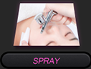to enter the following interface
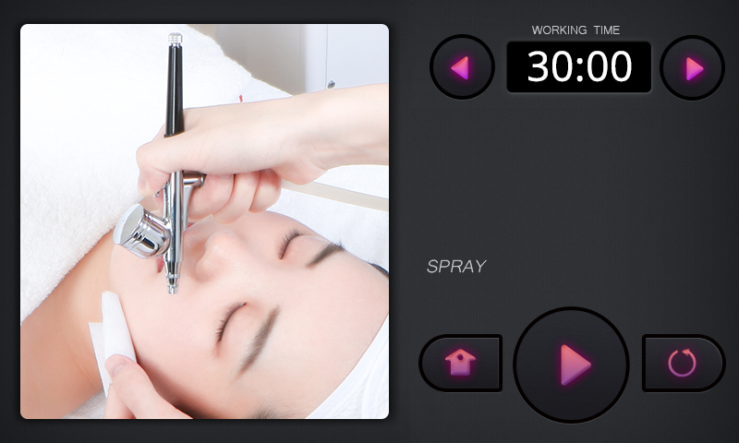
working time adjustment
After setting time, press to start the treatment

9. Detailed Operation of DERMABRASION
choose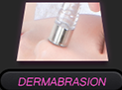to enter the following interface
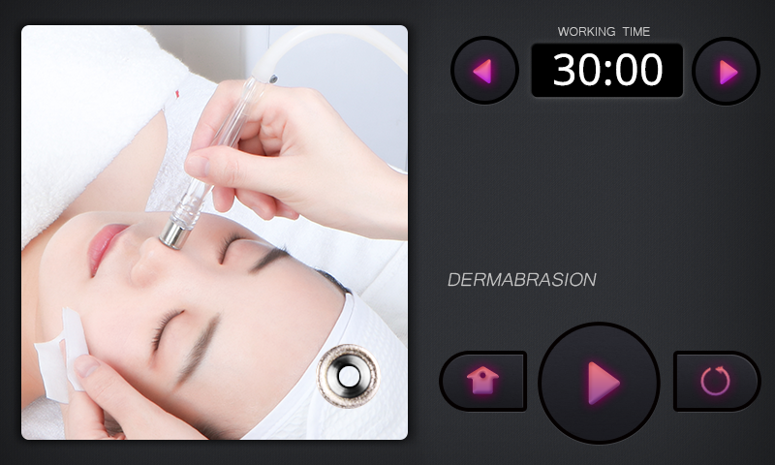
working time adjustment
After setting time, press to start the treatment
- Detailed Operation of BIO
choose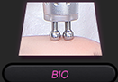to enter the following interface
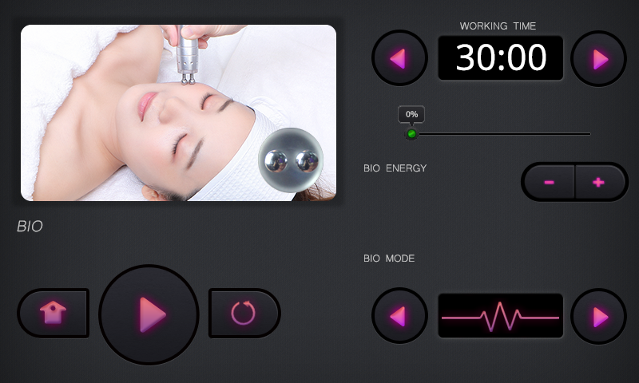
working time adjustment
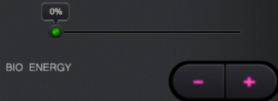energy level and adjusting buttons
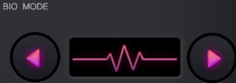mode switching (constant working mode and discontinuous working mode)
After setting time, energy level, and mode, press to start the treatment.
- Detailed Operation of Lipo Laser
choose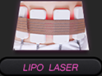to enter the following interface
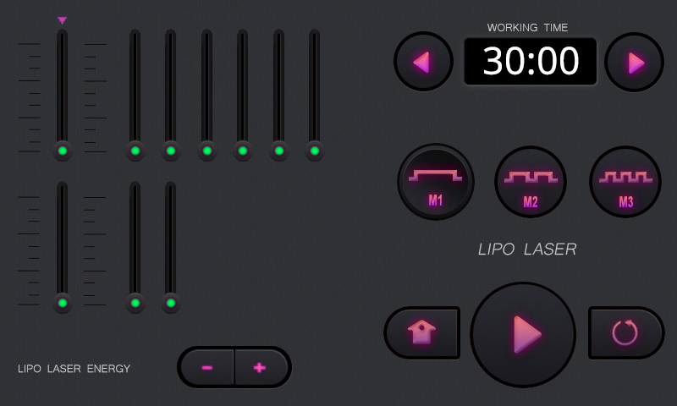
working time adjustment
buttons for adjusting energy level
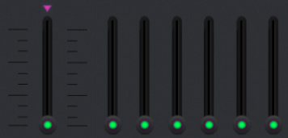energy-displaying bars for large lipo laser pads
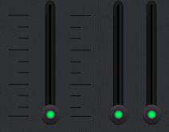energy-displaying bars for small lipo laser pads
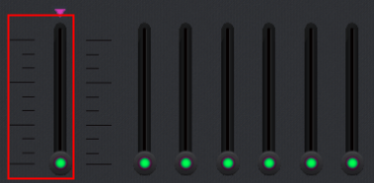When choose the leftmost bar, and then press the buttons for adjusting energy level, the energy level of all lipo large laser pads can be adjusted simultaneously (the same case for the small laser pads)
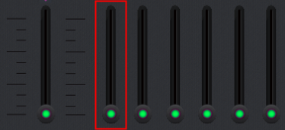When you choose one of the six energy-displaying bars on the right side and then press the buttons for adjusting energy level, the energy level of corresponding lipo laser pad can be adjusted. (the same case for the small laser pads)
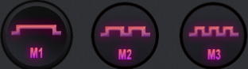three working modes of the lipo laser pads.
M1：the lights are constantly on
M2：the lights flash with low frequency
M3：the lights flash with high frequency
The longer the lights act on skin, the better the treatments effects will be. Choose proper mode based on individual situation.
After setting time, energy, and mode, press to start the treatment.

Technical Specifications
Power supply Input: 100V-240V
Power: 390W

Unoisetion 40K cavitation Head:
Frequency: 40KHz
Power: 45W

8 Pole 3D Smart RF w/Photon for body
Frequency: 1MHz
Power: 45W

Quadrupole 3D Smart RF w/Photon for face
Frequency: 1MHz
Power: 35W

3D Smart Bipolar RF w/Photon for eye area
Frequency: 1MHz
Power: 25W

Bipolar SMART RF w/ vacuum for face & eyes
Frequency:1MHz
Power:20W
Vacuum: <-80kPa
Pressure: >250kPa
Air flow: >10L/minute
Noise level: <70dB (30cm away)

Dermabrasion
Power: 45W
Vacuum: <-80kPa
Pressure: >250kPa
Air flow: >10L/minute
Noise level: <70dB (30cm away)

Nozzle Diameter: 0.2mm-0.3mm
Fluid Cup Capacity: 7cc
Weight: 289 g / 10.19 oz

3. Dos and Don’ts

1. The plug with grounding pin must be used before the instrument is used and the power socket of the instrument is properly grounded.

2. Ensure that the voltage of the instrument is suitable. If the voltage of the local power supply is not stable, we suggest that the user add a voltage regulator with matching power between the mains and the instrument.

3. In order to ensure the treatment effect and normal service life of the instrument, please use the specified parts provided or suggested by the original manufacturer.

4. The instrument should not be placed in damp places or near water sources, and should not be directly exposed to sunlight.

5. Do not place the instrument near a strong heat source, as this may affect the life and normal use of the instrument.

6. Before treatment, please remove all metal objects from the body first, so as to avoid unexpected conditions and influence the curative effect.

7. Please restrain from using the device on eyes, thyroid, parathyroid, testicles, abdomen of pregnant women, and pacemakers.

8. Patients who are suffering from illness should consult with a doctor and gain permission from the doctor before using.

9. Please turn off the power switch of the device, and ensure that the total power supply of the device is turned off before the staff leaves after daily use, so as to ensure the safety of the electrical products.
- During the dermabrasion or vacuum treatment, set the energy at the lowest level at the beginning and increase the level slowly after treatment receiver adapts.
- Do install the rubber seal during the operation of dermabrasion. Otherwise, there is no suction or weakened suction.
- Filter cotton must be used in the dermabrasion treatment in case dirt is absorbed into the tube and causes damages to machine.
- 40K function can not be used on the areas next to heart, like chest, back and head.
- Make sure the target area is kept moistened to make treatment receiver feel comfortable. Do on perform treatments on dry skin (except for the lipo laser treatment)
15. Please inform the treatment receiver of possible sensations of micro electric currents before treatment.
16. Cleaning the dermabration tip is a must, which can prevent cross infection. Brush dirt and grime out of the tip, rinse the tip with clean water, soak the tip in ethanol for 3 minutes and then rinse the tip again to remove ethanol.
17. Please make sure you can distinguish the suction hole from the air outlet. Do not connect the oxygenation sprayer to the suction hole, otherwise the machine will be broken.
18. The liquid used in the oxygenation sprayer should be watery fluid. The possibility is there will be blockage and machine may get broken if you pour thick skincare products into it.
19. When you use the oxygenation sprayer on the customer’s philtrum, please let customer change her/his way of breathing.
20. Clean the instrument with normal saline after operation to ensure its cleanliness and hygiene and prolong its service life.
21. Use machine or train machine operators in strict accordance with instructions in the user manual.

4. Troubleshooting & Solutions

1. The machine cannot be started?
A. Make sure the power cord is connected to the socket with normal power supply.
B. Please check whether the power cord is properly connected to the socket at the back of the machine

2. The machine can be started but the cold hammer doesn’t work?
A: The cooling fan inside is broken and then doesn’t work
B: The circuit board inside is loose or damaged
C: If aforementioned problems occur, you need to replace the handpiece.

- The machine can be started, but there is no electric currents during the BIO treatment.
A: Please check whether the start button on the control panel is pressed.
B: Please check whether the handpiece is connected to the machine body properly.
C: Please check whether there is liquid medium on face, for there are obvious sensations only when mediums are applied to the target area.
D: If it is not any case mentioned above, the handpiece may be broken. You need to contact after-sale service staff for solution.

- There is no spray coming out when using the sprayer?
A: Please check whether the nozzle of the sprayer is blocked.
B: Please check whether the sprayer is connected to the machine properly.
C: Please check whether the small lever on the sprayer comes loose.

5. There is no suction when the dermabrasion treatment is performed?
A. Please check whether the hose is connected to the machine properly.
B. Please check whether the hose and dermabrasion handpiece are connected or whether the connection is correct.
C. Please check whether the rubber ring is put in place.
D. Please check whether the suction knob is turned to the minimum scale.

6. The machine can be started, but there is weakened or no RF output?
- Please check whether the handpiece is connected to the machine properly.
- Wire in the handpiece comes loose or is burnt out.

7. There is no or weakened suction when using the Vacuum&RF handpiece?
A: Please check whether the filter has been installed correctly
B: Please check whether the handpiece is connected to the machine properly.
C: Please check whether the cord connecting the handpiece to the machine is broken
D: Please check whether there is blockage due to dirt or foreign object at the suction hole. If so, clean the suction hole.
E. Please check whether the suction knob turned to the minimum scale.

FAQs
- Q: Why do we need to exfoliate skin?
A: The stratum corneum is a layer above the epidermis, on which the cells have completely died. Depending on different parts of the body, the stratum corneum is composed of 15 to 20 layers of dead cells. Human skin has a metabolic cycle, normally 28 days, which is the metabolic cycle of people in adolescence. If you are an adult, your metabolic cycle should be 10 days more than your age value. However, due to various reasons, it is possible that the aging and dead cells can not fall off in time, resulting in corneum hypertrophy, and the skin has no sense of transparency, which affects the skin color and the metabolic renewal of the skin. Therefore, in the case that there is no way to normally complete this normal metabolic process, it is necessary to use artificial methods to achieve the goal.

- Q: Can I put on makeup after operating this instrument?
A: Absolutely you can. After treatment, the skin is moisturized and plump, and putting on make-up will see better effect at that time. This is a non-invasive skin care, which is safe, healthy, fast and effective.

- Q: How long can I see the effect after taking the face nutrient introduction treatment?
A: After one treatment, you will find your skin will be clear with clarity. Taking more treatments can help deliver more noticeable effects. Skin problems such as dryness, darkness, fine lines and large pores can be dramatically relieved.

- Q: What is collagen?
A: Collagen is a kind of biological macro molecule substance, a kind of white, opaque and non-branched fibrous protein. It can supplement the nutrients needed by all layers of the skin, enhance the collagen activity in the skin, retain moisture, nourish skin, slow down ageing, relieve facial relaxation, provide nutrients for the hair and so on. Collagen is a nutrient that human body must replenish to delay ageing. With the growth of age, collagen will gradually be lost. For women, collagen will begin to decrease since the age of 20. At the age of 25, collagen loss will reach its peak. At the age of 40, the collagen content is less than half of that one has at age of 18. It is the loss of collagen and water that causes the wrinkles on the face of the elderly. The breakage of collagen fibers and elastic fibers will cause skin tissue to be oxidized, atrophied and collapsed. The skin will be dry, wrinkled, flabby and inelastic. Therefore, in order to delay ageing, there must be plenty of collagen.

- Q: Will skin become thinner and more sensitive after taking diamond dermabrasion treatment?
A: No. It only removes the aging stratum corneum of the skin in the process of operation. Our skin will be updated every 28 days, so it will only make the skin more and more smooth, delicate and transparent without sensitive symptoms.

- Q: Is there any dependence on taking this treatment?
A: No dependence. This is aimed at refining and cleaning the skin, which belongs to the maintenance product that helps skin avoid problems caused by other factors, help the skin absorb nutritional products, relieve skin dullness, dryness and roughness and wrinkles. If you do not take this treatment in the later stage, skin will just return to previous secretion and aging process, and that will not cause dependence.

7. Q: Does ultrasound treatment have side effects on human body?
A: Ultrasonic beauty treatment is non-surgical and non-invasive program without anaesthesia. It relies on ultrasound (mechanical sound wave) - dissolve fat through cavitation - ultrasound focusing. And the results are fat smash - fat dissolving - skin firming and body sculpting respectively. It only targets low-density fat cells but leaves high-density tissue like blood vessels intact, and therefore has no side effects on human body. Slight tinnitus will probably occur during the treatment, which is within normal range. So there’s no need to worry about that.

8. Q: How long does it take before I start seeing results of RF treatment?
A: Normally, you can see the treatment results that day when you take the operation or within one week. Skin collagen tissue is heated and then contracts, and you can obviously feel the sensation of skin being tightened. Because RF works to stimulate subcutaneous tissue to promote collagen regeneration, so the more you take the treatment, the more noticeable the effects will be.

9. Q: Is RF harmful to skin?
A: RF treatment is non-surgical operation. It stimulates collagen regeneration at the skin bottom and boosts metabolism, and therefore has no damage to the skin. Local redness and hotness are the normal conditions of accelerated blood circulation, which will be relieved after a moment. So there’s no need to worry about that.

10. Q: How long does the body-firming treatment take?
A: One treatment session is 60 minutes. We will combine professional techniques and instruments to achieve remarkable results.

11. Q: What functions does this instrument have?
A: It has the functions of dissolving fat and shaping body, smoothing & rejuvenating skin, relaxing and repairing skin, firming &lifting skin and anti-aging. It can be operated on every part of the body. In terms of facial care, it can form face contour, alleviate wrinkles and saggy skin. In terms of body care, it can reduce regional fatness and build S-shaped curve, and promote metabolism and detoxification of the whole body. Meanwhile, it can also enhance the functions of viscera and solve sub-health problems.

- Q: Which one is better in terms of weight loss, liposuction or this machine?
A: The principle of liposuction is to suck out the excess fat in one part of the body through negative pressure suction so as to achieve the purpose of rapid weight loss. It’s a surgical treatment requiring anesthesia and so there is recovery period, which has risks despite its immediate results. However, our instrument is risk-free without side effects. It can not only help you reduce fat but also stimulate collagen regeneration to lift and tighten skin. It can also build perfect curves by lifting skin, and accentuate women's sexual charm.

- Q: Will I regain weight after operation?
A: The 40K treatment works to dissolve fat to reduce weight, and users are not prone to regain their weight. Because what’s dissolved through this treatment is fat, not water. Fat needs a longer period of time to accumulate, so normally people will not regain weight.

- Q: Does RF have side effects on the body?
A: RF beauty treatment is non-invasive and is one of the most effective and the safest approach to remove wrinkles and shape body. Generally speaking, side effects won't appear. A small number of people may experience transient redness or swelling that will disappear after a few hours. Those with dry skin may experience atrophy after treatment, which will disappear after three days because collagen regeneration will make skin plump up though RF heat can cause moisture loss of skin. Overall, there are no side effects on people’s health.

- Q: Can ultrasound treatment be performed on every part of the body?
A: Ultrasound treatment works to rupture fat cells, by which fat is released from cells and then metabolized through lymphatic system. So its power is very high. Heart is sensitive to high frequency sound waves since it is a hollow organ. After being vibrated by sound waves, the heart will reflect the waves due to the different transmission of sound waves by the muscle tissue and the blood in the heart. This force can pulls valves away from the heart muscle. If you use the instrument on eyes, it can lead to retinal detachment, so the ultrasound treatment should not performed on the areas of eyes and heart. (not on the areas of waist, back and chest)

16. Q: Why does tinnitus occur?
A: It’s because ultrasound comes with a high frequency vibration, which could go up to 20kHz. It penetrates into 20mm-deep skin fat layers through ultrasound focusing. Highly intensified ultrasound can cause high-speed friction among fat cells, which can heat and dissolve them. And during the process, sound may be produced so that customer will have the sensation of tinnitus.

17. Q: Which is better when it comes to this treatment and liposuction?
A: Compared to traditional liposuction, this treatment uses equal laser energy to reduce fat on every parts of the whole treated area, which will not cause skin unevenness instead of smoothing and tightening skin. Moreover, the applied laser acts only on the fat layer. It not only does no harm to epidermis, but accelerates the repair of elastic fibers to keep the tightness and smoothness of the treated area.

18. Q: Will there be a rebound through laser fat-dissolving?
A: The number of adipose cells in the body is fixed, which will not see change in adulthood. The increase in weight is due to the increase in the volume of adipose cells. Laser fat-dissolving treatment will destroy localized fat structure, and then reduce the volume of fat. Admittedly, rare occurrence of regaining weight does not mean that it will not be seen again. In general, as long as one’s diet is reasonable and binge eating is avoided, he will not experience weight gain.

- Q: Does people need to control food intake and take exercise when they lose weight by laser treatment?
A: The efficacy of losing weight by laser is more significant, but we can not blindly rely on it. For example, one’s weight will reach the ideal range by using it. But if he does not pay attention to diet control and overeat, then it is likely to lead to weight gain. There is no weight-losing product in the world that absolutely guarantees that it has permanent efficacy. So losing weight by laser is a helping way. When the weight reaches the ideal range, we should also reasonably plan our own diet and take reasonable exercise after stopping using it.

- Q: Why do I need hip treatment?
A: Because it can help with detox of lymphatic system of body, relieve gynecological diseases, and protect women from harm brought by buttock blockage. Hip blockage will bring about gynecological conditions for the fact that hips are the areas where many important organs of human body exist. If hips suffer from the squeeze of upper and lower energizer meridians, they will be vulnerable to cold, damp and blood stasis. When hips are affected by cold, hip meridian contraction will occur, and then there will be some symptoms such as dysmenorrhea, irregular menstruation, dark menses, blood clot, blood and meridian blockage. It also affects women’s fertilization.

- Q: How does vacuum detoxify?
A: Vacuum can cause capillary congestion, stimulate cell to increase vitality. The suction and release of pressure during operation can make local pores continue to open and close, which can promote skin breathing, increase the amount of skin oxygen, and speed up waste removal. So it achieves the effects of promoting qi and blood circulation, dispelling cold and damp, dredging meridians and collaterals, clearing toxins, dissipating heat and so on.

6. Packing List
1x Machine Body
3x Filter
1x BIO Handpiece
1x 3D 4-poled RF Handpiece
1x 3D 2-poled RF Handpiece
1x 3D 8-poled RF Handpiece
1x 6-poled Vacuum RF Handpiece
1x 40K Handpiece
1x Bipolar Vacuum Handpiece
1x Oxygenation Sprayer
9x Dermabrasion Tip
3x Dermabrasion Handpiece
6x Large Lipo Laser Pad
2x Small Lipo Laser Pad
2x Fuse
1x Holder
Several rubber rings
1(parcel)x Filter Cotton
1x Black Hose
1x Red Hose
1x Power Cord

7. Simplified Treatment Steps

- Skin cleansing & rejuvenation
Treatment steps: remove makeup--apply blackhead-removing liquid and hot steam--dermabrasion treatment--clean face--apply essence and water and use oxygenation sprayer--apply essence and take BIO treatment--apply hydro face mask--clean face--apply face mask--remove mask and clean face--apply toner, essence and face cream.
Needed skincare products: makeup remover, face cleanser, hydro face mask/blackhead-removing liquid, massage cream, face mask, toner, essence and face cream.

- Skin firming & lifting
Treatment steps: remove makeup and clean face--apply toner--apply massage cream and take 3D FACE RF treatment--apply massage cream and take 2-poled Vacuum & RF treatment--clean face--apply essence and take BIO treatment--clean face--apply face mask--remove mask and clean face--apply toner, essence and face cream.
Needed skin products: makeup remover, face cleanser, massage cream, face mask, toner, essence, face cream.

- Eye anti-wrinkle
Treatment steps: remove makeup--apply toner--eye essence and massage techniques--apply eye essence and perform 3D EYE RF treatment--clean eye area--apply eye essence and perform BIO treatment--apply eye mask--clean eye area--apply toner, eye essence and eye cream.
Needed skincare products: makeup remover, face cleanser, eye mask, toner, eye essence, eye cream.

- Neck care
Treatment steps: remove makeup--apply toner--massage techniques--apply massage cream and perform 3D FACE RF treatment--apply massage cream and perform bipolar vacuum & RF treatment--clean neck--small lipo laser pads--clean neck--face mask--clean neck--apply toner, essence, neck cream.
Needed skincare products: makeup remover, face cleanser, massage cream, neck mask, toner, neck essence, neck cream.

- Abdomen/arm/leg
Treatment steps: massage techniques--Body RF--40K--6-poled vacuum & RF--large lipo laser pads.
Needed skincare products: essential oil, RF cream, gel

- Back
Treatment steps: massage techniques--Body RF--6-poled vacuum & RF--large lipo laser pads.
Needed skincare products: essential oil, RF cream

- Hip
Treatment steps: massage techniques--Body RF--6-poled vacuum & RF
Needed skincare products: essential oil, RF cream

8. Operational Diagrams

Parameter  Adjustment | Products | Techniques | Diagrams
Skin cleansing&rejuvenation: 70 min once a week
Dermabrasion  Time: 8-10 min  Oxygenation Sprayer  Time: 5 min  BIO  Time: 10 min  Energy level: 30%-70%  Mode: constant working mode | Makeup remover+face cleanser+blackhead-removing liquid+hot&cold steam+face mask+YH-9801S | - Remove make-up and clean face, 5 minutes  - Apply blackhead removing liquid and hot steam (Apply blackhead removing liquid to T zone. Toner can be applied to cheeks. If you have sensitive skin, apply toner and hot steam on the whole face), 8-10 min.  - Dermabrasion treatment (wait for 5 minute after the hot steam): move the dermabrasion tip from jaw to the back of ear, mouth corner to ear center, and nose wing to temple by by line, 3-6 times.  - Repeat the techniques on the other side.  - Move the dermabrasion tip towards hairlines on forehead, 3-6 times.  - Wash face clean, 2 minutes.  - Oxygenation sprayer treatment: pour essence (for whitening/hydration, soothing/anti-ageing)into the container(if the essence is thick, dilute the essence with distilled water at a ratio of 2:1), 2 minutes.  8. Move the handle upwards line by line from jaw to earlobe, mouth corner to ear center, and nose wing to temple in conjunction with gentle pressing technique of the other hand  9. Move the handle towards hairline on forehead in conjunction with gentle kneading technique of the other hand.  10. BIO treatment: move the handpiece from jaw to the back of ear, mouth corner to ear center, and nose wing to temple in spiral curve  11. Repeat the techniques on the other side.  12. Move the handpiece towards hairlines on forehead, 3-6 times.  13. Wash face clean, 2 minutes.  14. Apply hydro face mask, wait for 10 minutes.  15. Remove mask and clean face, 2 minutes.  16. Apply face mask, 15 min.  17. Remove mask and clean face, 2 minutes.  18. Apply toner, essence, face cream and suncream.  19. The end. | Technique3  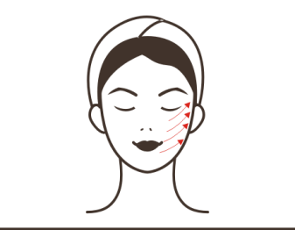  Technique5  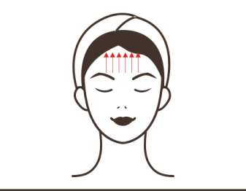  Technique8, 9  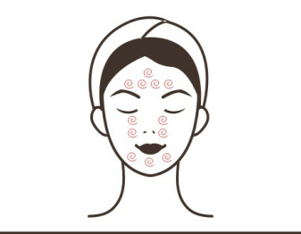  Technique8  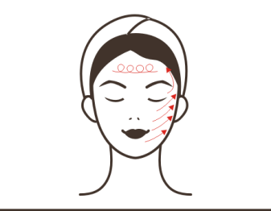  Technique10, 11, 12  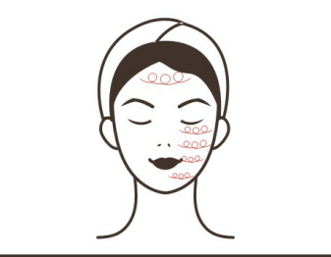
Treatment Suggestion
One course of treatment consists of ten treatment sessions. After one treatment, skin will be thoroughly cleansed with pores unblocked. One course of treatment will help relieve skin’s roughness and strawberry-like nose. After three courses of treatment, skin will be smoothed and rejuvenated and with skincare products absorbed more efficiently.
Skin firming&lifting: 90 min once a week
3D FACE RF  Time: 10 min  Energy level:30%-70%  Mode: NOR (default)  Lights: choose based on your needs.  2-poled Vacuum&RF  Time: 10 min  RF energy level: 30%-70%  RF mode: NOR (default)  Suction time&release time: adjust them based on individual needs or choose preset Suction&Release mode.  M1 mode is recommended  Suction level：adjust it based on individual endurance.  BIO  Time: 10 min  Energy level: 30%-70%  Mode: constant working mode(recommended) | Makeup remover+face cleanser+hot&cold steam+massage cream+hydro mask+essence+face mask | - Remove makeup and clean face, 5 minutes.  - Apply hydro mask and hot steam, 10 minutes  - Clean the face, 2 minutes.  - Apply toner, 1 minute  - Apply massage cream evenly to face and soothe face, 3 times.  - Apply digital pressing technique on the following acupoints (RN-24, DU-26, ST-4, ST-6, LI-20, BL-1, BL-2, EM3, TE-23, the temple, GB-1, ST-1, ST-2), 3 times.  - Soothe face, 3 times  - Alternately apply lifting technique from chin to ear lobe, mouth corner to Ermen(SJ21), and nose wing to temple, lift eye corner from lower eyelid to temple with both hands, 3 times.  - Repeat the technique on the other side.  - Apply lifting technique towards hairline on forehead, 3 times  - Apply plucking technique with fingers alternately to lift face.  - Apply plucking technique with one hand towards hairline on forehead.  - One side, apply plucking technique with both hands alternately to lift face, 2-3 minutes  - Repeat the technique on the other side.  - Move in a zigzag motion on forehead with middle and ring fingers, slide to the front side of ears and lift back and forth for 3 times and then slide to the back of ears.  - The end  - 3D Face RF operation  18. Apply lifting technique from jaw to earlobe, mouth corner to ear center, and nosewing to temple by moving the handle line by line, 3 times.  19. Repeat the technique on the other side.  20. Apply lifting technique by moving the handle towards hairline on forehead, 3 times.  21. 2-poled Vacuum & RF operation: lift from chin to earlobe, mouth corner to ear center and nose wing to temple line by line, 3 times.  22. Repeat the techniques above on the other side.  23. Move the handpiece towards hairline on forehead, 3 times.  24. Clean face, 2 minutes.  25. Apply essence evenly to face.  26. BIO treatment: lift from chin to earlobe, mouth corner to ear center and nose wing to temple line by line or in circular motion, 3 times.  27. Repeat the techniques above on the other side.  28. Move the handpiece towards hairline on forehead line by line or in circular motion, 3 times.  29. Clean face, 2 minutes.  30. Apply face mask, 15 min.  31. Remove mask and clean face, 2 minutes.  32. Apply toner, essence, face cream and suncream.  33. The end. | Technique5, 7  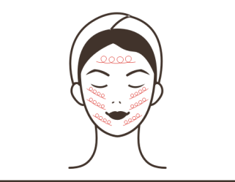  Technique6  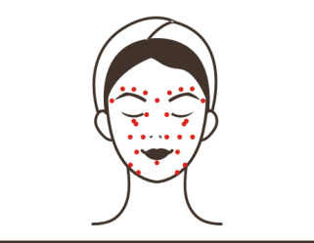  Technique8, 9, 21, 22  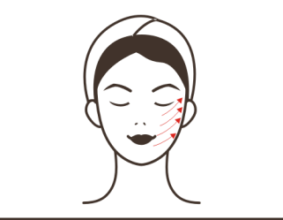  Technique10, 23  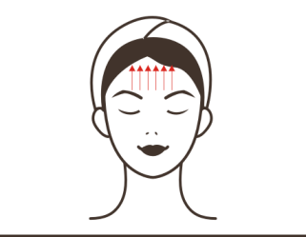  Technique15  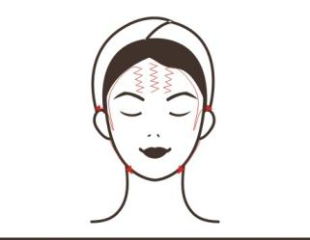  Technique18, 19, 20, 26, 27, 28  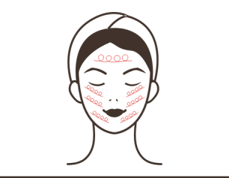  20, 28  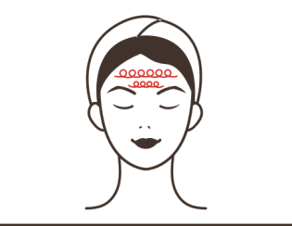
Treatment Suggestions
One course of treatment consists of ten treatment sessions. After one treatment session, skin will be firmed and rejuvenated as the nutrients it needs are absorbed. After one course of treatment, skin will lifted with glow. Two courses will make skin smooth and plump, leaving face contour clearer. Three courses will promote skin metabolism and detox processes, help fade pigmentation and skin darkness, slow down skin ageing and prevent skin from sagging, and stimulate collagen regeneration to leave skin smooth and firm with glow.
Eye Anti-wrinkle: 60 min once a week
3D EYE RF  Time: 10 min  Energy: 30%-70%  Mode: NOR (default)  BIO  Time: 10 min  Energy level:30%-70%  Mode: constant working mode(recommended)  Lights: choose based on your needs. | Makeup remover+face cleanser+essence/eye cream+YH-9801S+eye mask | - Remove makeup and clean face, 5 minutes.  - Apply toner, 1 minute  - Rub essence (eye cream) evenly into the area round eyes by moving in circular motion, 3 times.  - Press acupuncture points on eye area: BL1, ST1, ST2, GB1, SJ23, EX-HN4, BL2.  - Soothe eye area with right hand and left hand moving clockwise and anticlockwise respectively, 3 times.  - Use scissor-hand to soothe eye area.  - Use one hand to move in circular motion from inner eye corner to the outer eye corner and finally to the back of ear, with the other hand in scissor shape, 3 times.  - 3D Eye RF operation: apply lifting technique by moving the handpiece from lower eyelid to eye corner, 3-6 times  9. Apply lifting technique by moving the handpiece from lower eyelid to temple, 3-6 times  10. Apply lifting technique by moving the handpiece in small circles from lower eyelid to temple, 3-6 times.  11. Apply lifting technique by moving the handpiece from lower eyelid to temple, 3-6 times  12. Apply lifting technique by moving the handpiece from eyebrow to hairline, 3-6 times.  13. Repeat the techniques on the other side.  14. Wash eye area clean, 1 minute  15. BIO treatment: apply lifting technique by moving the handpiece from lower eyelid to eye corner, 3-6 times  16. Apply lifting technique by moving the handpiece from lower eyelid to temple, 3-6 times  17. Apply lifting technique by moving the handpiece in small circles from lower eyelid to temple, 3-6 times.  18. Apply lifting technique by moving the handpiece from lower eyelid to temple, 3-6 times  19. Apply lifting technique by moving the handpiece from eyebrow to hairline, 3-6 times.  20. Repeat the techniques on the other side.  21. Wash eye area clean, 1 minute  22. Apply eye mask, 15 min.  23. Remove mask and clean the area, 2 min.  24. Apply eye essence.  25. The end. | Technique3, 5  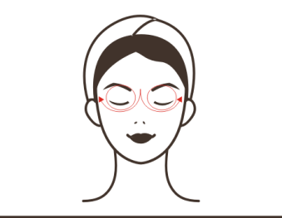  Technique4  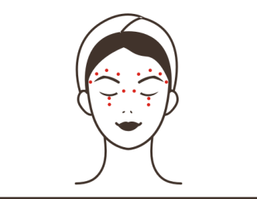  Technique6  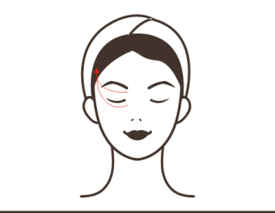  Technique7  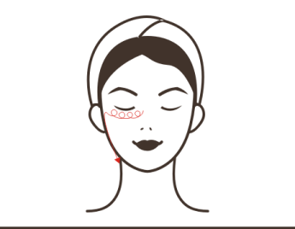  Technique8, 15  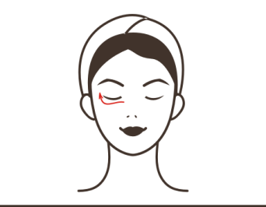  Technique9, 16  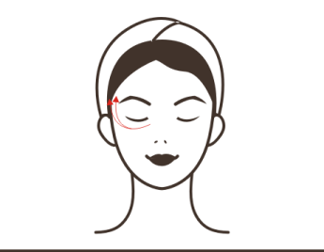  Technique10,17  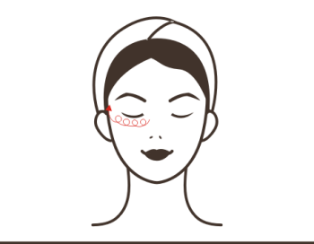  Technique11, 12, 18, 19  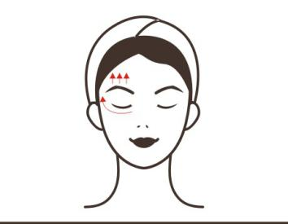
Treatment Suggestions
One course of treatment consists of ten treatment sessions. After one treatment, metabolism will be accelerated, skin around eyes will be tightened and fine lines will be reduced. After one course of treatment, fine line will be obviously removed. Two courses of treatment will help lift skin due to the collagen growth at deep skin, leaving eye corners lifted and eyes brighter. Three courses of treatment will help consolidate effects and fine lines will be totally gone. If the treatment receiver keeps daily care, wrinkles will be prevented from reappearing.

Neck Care: 70 min once a week
3D FACE RF  Time: 10 min  Energy level:30%-70%  Mode: NOR (default)  Lights: choose based on your needs.  2-poled Vacuum&RF  Time: 10 min  RF energy level: 30%-70%  RF mode: NOR (default)  Suction time&release time: adjust them based on individual needs or choose preset Suction&Release mode.  M1 mode is recommended  Suction level：adjust it based on individual endurance.  Small lipo laser pads  Time: 15 min  Energy level: 30%-70%  Mode: M1(recommended) | Makeup remover+face cleanser+massage cream+essential oil+neck mask | - Remove makeup and clean neck, 5 min.  - Apply toner, 1 min.  - Neck massage: rub oil into the chest with both hands to the back of the neck and press Gb-20 and Du-16 acupoints, 3 times.  - Alternately lift the lower jaw and double chin and then pass behind the ear and under the armpit, 3 times.  - Push downwards with thumb and index finger splaying, tracing 3 meridians from the neck to the armpit, 3 times.  - Push downwards with 4 fingers, tracing 3 meridians from neck to the armpit, 3 times.  - Push downwards with bending fingers till the neck turns hot and slide to the armpit, 3 times.  - Push downwards with thumb and index finger splaying from outer collarbone to armpit, 3-5 times.  - Do the same on the other side.  10. The end  11. 3D Face RF operation, move the handle from double chin area to the back of ear and then to armpit in circular motion, 3 times.  12. Move the handle in circles along three lines on one side of neck to armpit, 3 times.  13. Move the handle in circles on the whole neck area to armpit, 3 times.  - 2-poled Vacuum&RF treatment: move the handpiece under the earlobes at both sides of neck (do not perform treatment on arteries).  - Small lipo laser pads treatment: wrap the strap around the treatment area, and fix the laser pads into the strip, set energy level, wait for 15 minutes.  - Remove the lipo laser pads and untie the strap.  - Wipe neck clean with hot towel, 2 min.  - Apply neck mask, 15 min.  - Wash the area clean with warm towel and apply the warm towel to neck for 1 minute.  - Apply toner, essence, face cream and suncream.  - The end. | Technique3  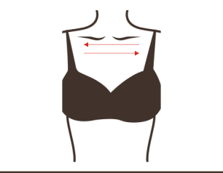  Technique4, 6, 7, 14  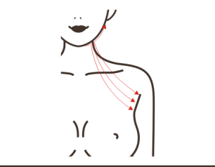  Technique8  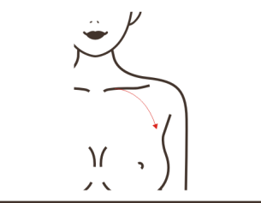  Technique5, 11, 12, 13  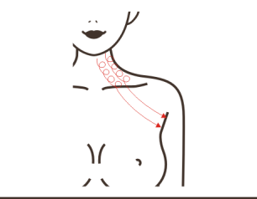
Treatment Suggestions
A course of treatment consists of ten treatment sessions. After one treatment, skin becomes rejuvenated and smooth. After a full course, neck skin becomes smooth, and the neck lymphatic circulation is accelerated. After 2 courses of treatment, skin will be tightened, neck lines will be reduced, and the condition of double chin will be relieved. After 3 courses of treatment, skin will be firmed with glow, lymphatic detox will be accelerated, and some problems will be resolved such as acne and skin dullness. Moreover, skin aging will be prevented and skin will remain in a young state.
Waist&abdomen Shaping: 80 min once a week
Body RF  Time: 15 min  Energy level: 30%-70%  Mode: NOR (default)  40K  Time:15 min  Energy level: 30%-70%  Mode: constant working mode  6-poled Vacuum&RF  Time: 15 min  RF energy level: 30%-70%  RF mode: NOR (default)  Suction time&release time: adjust them based on individual needs or choose preset Suction&Release mode.  M1 mode is recommended  Suction level：adjust it based on individual endurance.  Large lipo laser pads  Time: 20 min  Energy level: 30%-70%  Mode: M1(recommended) | Massage cream (essential oil) +gel+YH-9801S | - Massage techniques  - Rub oil into abdomen with hands moving in circular motion, 3 times.  - Rub abdomen back and forth with both hands, 3-5 times.  - Knead abdomen with both hands using chiropractic technique, 3 times.  - Lift Meridian BV(Belt Vessel) on both sides of waist with both hands alternately, 16 times.  - Move hands in 8-shaped motion with right hand and left hand moving clockwise and anti-clockwise respectively on waist, 3 times.  - Overlap hands and message the intestinal canal clockwise, 3 times.  8. Move hands in circular motion to soothe the treatment area, 3 times.  9. Apply digital pressing technique on the following acupoints: RN13, RN12, RN10, RN8, RN6, RN4, RN3, ST25, SP15. 2 times.  10. Starting from RN3 point, push to belly navel, slide to waist and then lift upwards to groin with both thumbs, 3 times.  11. Soothe the treatment area with hands and then slide to groin.  12. The end  13. Body RF operation: starting from one side of the waist, lift the handle to abdomen and groin, 3 times.  14. Repeat the previous operation on the other side, 3 times.  15. Move the handle on abdomen in small circular motion, 3 times.  16. Move the handle on abdomen in big circular motion, 3 times.  17. 40K treatment: techniques are the same with Body RF.  18. 6-poled Vacuum & RF operation: Suction & Release mode, move the cup from the left side of waist around belly button clockwise, 3 times.  19. Constant Suction mode, one side, lift from waist side to abdomen line by line, 3 times  20. Do the same on the other side  21. Lift Meridian BV (Belt Vessel) horizontally back and forth, 3 times  22. Move the cup up and down to shape waist, 3 times  23. Move cup in big circles on abdomen, 3 times  24. One side, lift from waist side to abdomen line by line, 3 times  25. Wipe the essence off abdomen with dry towel.  26. Large Lipo Laser pad treatment, wrap the binding strap around abdomen and fix laser pads into the strip, set energy level, wait for 20 minutes.  27. Remove the laser pads and untie the strap.  28. The end. | Technique2, 8  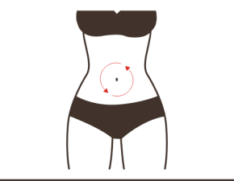  Technique3, 18  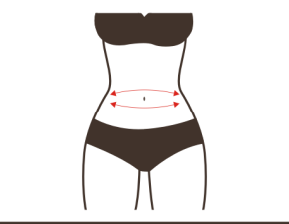  Technique4  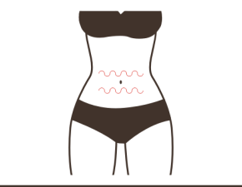  Technique5  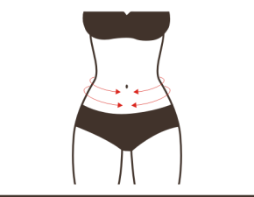  Technique6  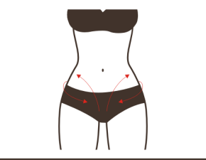  Technique7  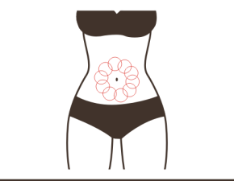  Technique9  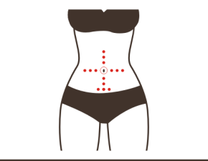  Technique10  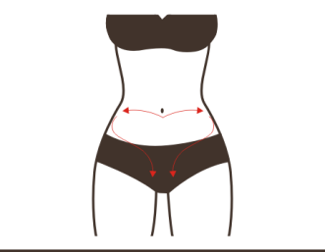  Technique13, 14, 19, 24  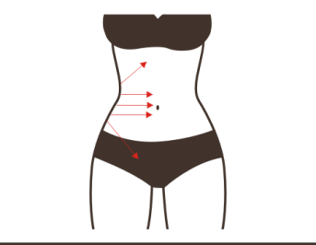  Technique15  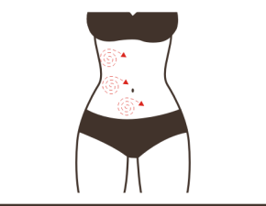  Technique16, 23  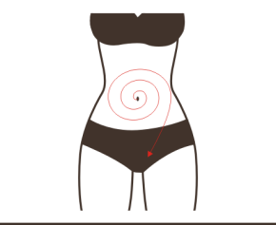  Technique21  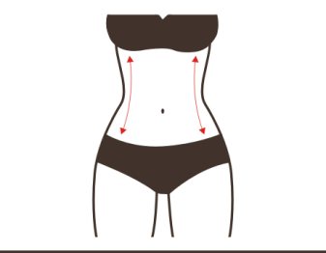
Treatment Suggestions
A course of treatment consists of ten treatment sessions. After one treatment session, metabolism will be accelerated. After one course, fat will be slowly metabolized, body will start to slim down. Constipation and other issues will be relieved at the same time. After two courses, the effects will gradually become obvious, skin will be tightened and lifted, and skin collagen will be increased. Stretch marks and flabby skin are also alleviated. Three courses will help consolidate the effects. Unwanted fat will gradually disappear, and waist and abdomen curves will start to take shape.
Arm shaping: 70 min once week
Body RF  Time:15 min (7-8 min on each side)  Energy level: 30%-70%  Mode: NOR (default)  40K  Time:15 min (7-8 min on each side)  Energy level: 30%-70%  Mode: constant working mode  6-poled Vacuum&RF  Time: 10 min (5 min on each side)  RF energy level: 30%-70%  RF mode: NOR (default)  Suction time&release time: adjust them based on individual needs or choose preset Suction&Release mode.  M1 mode is recommended  Suction level：adjust it based on individual endurance.  Large lipo laser pads  Time: 20 min  Energy level: 30%-70%  Mode: M1(recommended) | Massage cream (essential oil) +gel+YH-9801S | - Massage techniques  - Left-right order: lay the arm flat, rub oil into skin from lower arm to the entire arm and slide to the fingers (soothing technique), 3 times.  - Push the entire arm with both palms, 3 times.  - Push hands upwards tracing three meridians: Large Intestine Meridian (LI) - Triple Energizer Meridian(TE) - Small Intestine Meridian(SI) to armpits with thumbs and index fingers splaying, 3 times.  - Soothe the area, 3 times  - Rub three meridians on arms with bending fingers back and forth to warm them up, 3 times.  - Soothe the area, 3 times  - Lay inner arm upwards, and push hands tracing three yin meridians on inner arm: Lung Meridian (LU) - Pericardium Meridian(PC) - Heart Meridian(HT) to armpit with thumbs and index fingers splaying, 3 times respectively.  - Rub three meridians back and forth with bending fingers to warm them up, 3 times.  - Soothe the area and slide to fingers  - Repeat above techniques on the other arm.  - The end.  - Body RF treatment: lay customer’s arm flat, push three meridians from fat part of lower arm to armpit, 3 times.  - Move the handle in annular motion along three meridians to armpit, 3 times.  - Redouble the operation on flabby arms, 3 times.  - Move the handle along three meridians to armpit, 3 times.  17. Lay inner arm upwards and push three meridians on upper arm to armpit, 3 times.  18. Move the handle in circles along three meridians on upper arm to armpit, 3 times.  19. Move the handle along three meridians from upper arm to armpit.  20. Repeat those techniques on the other arm.  21. 40K treatment: techniques are the same with Body RF.  22. 6-poled Vacuum & RF treatment: move the handpiece on muscles and fat area of arm in Constant Suction status.  23. Large Lipo Laser pad treatment, wrap the binding strap around the fat area of arms, fix the laser pads into the strap, set energy level, wait for 20 minutes.  24. Remove the pads and untie strap.  25. The end. | Technique2, 3, 4, 5, 6, 7  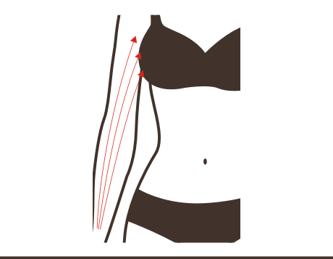  Technique8, 9  Technique10  Technique13, 16  Technique14, 15  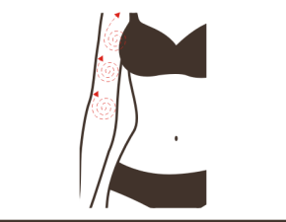  Technique17  Technique19
Treatment Suggestions
A course of treatment consists of ten treatment sessions. After one treatment session, it will feel warm and tight, and the arms will be relaxed. After one course of treatment, excessive fat on arms will be reduced and the skin will appear to be tight and plump. Two courses of treatment will help shape arms, dredge meridians, and enhance constitution to strengthen the effects. 3 courses will help consolidate effects and prevent arms from regaining fat.

Back shaping: 60 min once a week
Body RF  Time: 15 min  Energy level: 30%-70%  Mode: NOR (default)  6-poled Vacuum&RF  Time: 15 min  RF energy level: 30%-70%  RF mode: NOR (default)  Suction time&release time: adjust them based on individual needs or choose preset Suction&Release mode.  M1 mode is recommended  Suction level：adjust it based on individual endurance.  Large lipo laser pads  Time: 20 min  Energy level: 30%-70%  Mode: M1(recommended) | Massage cream (essential oil) +YH-9801S | - Massage techniques  - Apply oil to back and press Gb-20 and Du-16 acupoints.  - Pluck Dabanjing(the area connecting neck and shoulder) (from hairline), 3-5 times  - Move thumb outwards from Bladder Meridian (BL) to the sacral region and then to Gb-20 and Du-16 points.  - Starting from neck to caudal vertebra, move hands in S-shape, 3 times.  - Push Bladder Meridian (BL) with thumb in left-right order, 3 times.  - Push Bladder Meridian (BL) to the sacral region with both thumbs at the same time, 3 times.  - Push Bladder Meridian (BL) in three bending fingers, 3 times.  - Push along the medial border of scapula with both hands alternately in left-right order, 3-6 times.  - Push medial border of scapula with both hands horizontally, 3-6 times.  - Soothe the back with both hands and push Gb-20 and Du-16 points, 3 times.  - Overlap both thumbs and push SI-11 point and slide to the arm, 3 times.  - Do the same on the other side,3 times  - Rub Meridian GV and Bladder Meridian (BL) with hands to warm them up.  - The end  - Body RF operation, move the cup along Meridian GV and Bladder Meridian (BL) respectively from neck to the sacral region, 3-5 times.  17. Move the cup in circles on Du-14 point and sacral region, 3-5 times respectively.  18. From neck, move the cup on Dabanjing(the area connecting neck and shoulder) back and forth, 3-5 times.  19. Lift the cup on the medial border of scapula back and forth in left-right order, 3-5 times.  20. Lift from two sides of the waist upwards to armpit, 3-5 times.  21. 6-poled Vacuum & RF treatment: techniques are the same with Body RF  22. Wipe the area clean with dry towel.  23. Large Lipo Laser pad treatment, wrap the binding strap around the fat area of back, fix the laser pads into the strap, set energy level, wait for 20 minutes.  24. The end. | Technique2, 11  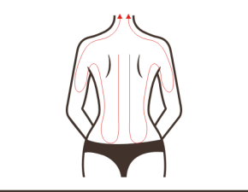  Technique3  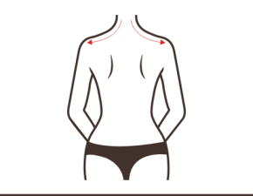  Technique4  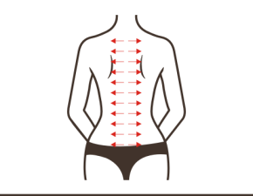  Technique5  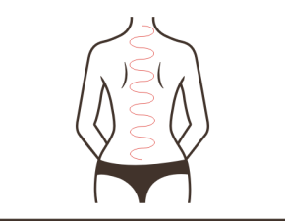  Technique6, 7, 8, 14  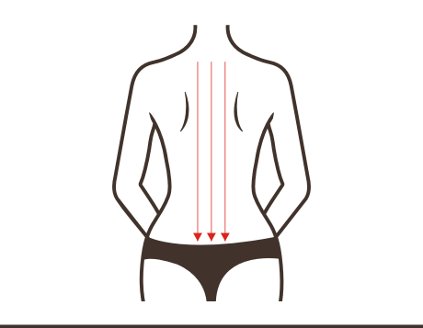  Technique9, 19  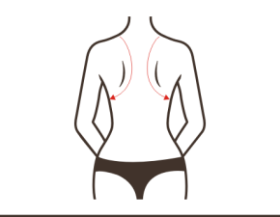  Technique10  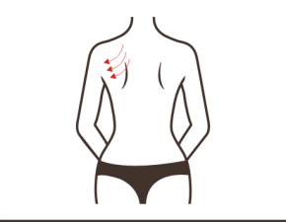  Technique12, 13  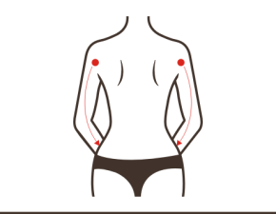  Technique16  Technique17  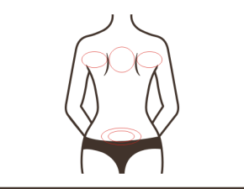  Technique18  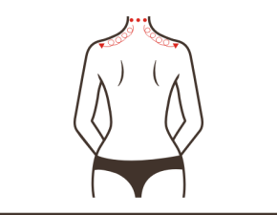  Technique20  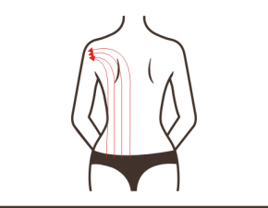
Treatment suggestions
A course of treatment consists of 10 treatment sessions. After one treatment session, back will be significantly relaxed, neck stiffness will also be alleviated, and skin will be lifted. A course will help relax shoulder, reduce back fat, relieve the lump on the nape of the back, and shape the back line. After two courses, the lump will appear to be smaller, meridians will be dredged, sub-health problems will be solved, and sleep quality will be improved. 3 courses will help with back thinning, back line refinement, strengthening visceral function, improving digestion, detoxification and metabolism (one course of treatment is to reduce fat, two courses are to strengthen effects, and three courses help with effect consolidation and prevent relapse.)

Hip Shaping: 45 min once a week
Body RF  Time: 15 min  Energy level: 30%-70%  Mode: NOR (default)  6-poled Vacuum&RF  Time: 15 min  RF energy level: 30%-70%  RF mode: NOR (default)  Suction time&release time: adjust them based on individual needs or choose preset Suction&Release mode.  M1 mode is recommended  Suction level：adjust it based on individual endurance. | Massage cream (essential oil) +YH-9801S | - Massage techniques  - Standing on the side, rub oil into skin by moving both hands clockwise and anticlockwise respectively from sacral region on hips, 3 times (this is soothing technique.)  - Apply pushing technique on the sacral region with two thumbs, 3 times.  - Soothe the treatment area for 3 times and then apply digital pressing technique on the following points: Bl-23, Baliao points (BL31-34), Du-1, Gb-30, BL-36, 3 times.  - Soothe the treatment area, 3 times.  - Left-right order, apply pushing technique from the top of thigh along the four meridians -- Bladder Meridian (BL) - Kidney Meridian (KI) - Liver Meridian(LV) - Gallbladder Meridian(GB) to Meridian BV respectively with both hands, 3 times each.  - Alternately apply pushing technique with both hands along Bladder Meridian (BL) - Kidney Meridian (KI) - Liver Meridian(LV) - Gallbladder Meridian(GB) from the top of thigh to Meridian BV respectively, 3 times each.  - Overlap both palms and then apply pushing technique from the top of thigh to Meridian BV (lifting), 3 to 5 times.  - Apply pushing technique from both sides of hips to the top of hips(shaping) back and forth, 3 times.  - Repeat technique 7  - Soothe the treatment area.  - Repeat the techniques above on the other side.  - The end.  - Body RF treatment: lift from the top of thigh to Meridian BV line by line, 3 times.  - Lift upwards from both sides of the buttocks to the highest point of the buttocks 3 times.  - Move in small circles on hip, 3-5 times  - Lift from the top of thigh to Meridian BV line by line, 3 times.  - Lift upwards from both sides of the buttocks to the highest point of the buttocks, 3 times.  - Do the same on the other side.  - 6-poled Vacuum & RF treatment: techniques are the same with Body RF  - Wipe hips clean with hot towel, 2 minutes.  - The end. | Technique2, 5, 11  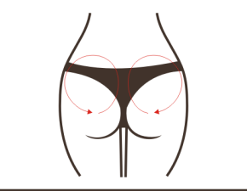  Technique3  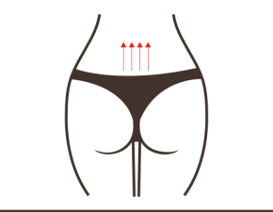  Technique4  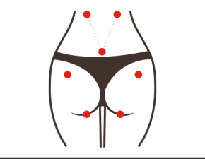  Technique6, 14, 17  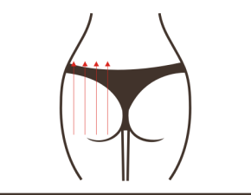  Technique7, 10  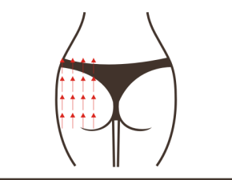  Technique9, 15, 18  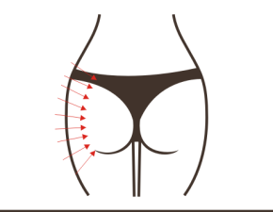  Technique16  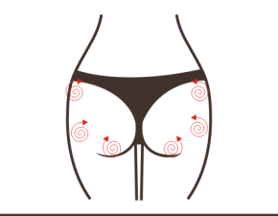
Treatment Suggestions
One course of treatment consists of 10 treatment sessions. After one treatment, buttocks will experience the sensations of being heated and lifted. After one course of treatment, buttocks start to show obvious curve lines, excessive fat begin to disappear slowly, and skin appear to be tight. After 3 courses, the conditions of cold body and uterus, other gynecological problems such as irregular menstruation are relieved, which can help consolidate the effect to mare females more attractive.

Leg shaping: 100 min once a week
Body RF  Time: 20 min (5 min on each side)  Energy level: 30%-70%  Mode: NOR (default)  40K  Time: 20 min (5 min on each side of leg)  Energy level: 30%-70%  Mode: constant working mode.  6-poled Vacuum&RF  Time: 20 min (5 min on each side of leg)  RF energy level: 30%-70%  RF mode: NOR (default)  Suction time&release time: adjust them based on individual needs or choose preset Suction&Release mode.  M1 mode is recommended  Suction level：adjust it based on individual endurance.  Large lipo laser pads  Time: 20 min  Energy level: 30%-70%  Mode: M1(recommended) | Massage cream (essential oil)+gel+YH-9801S | - Massage techniques  - Customer lies on his front, back side of the leg, left-right order: rub oil into the skin from calf to thigh and then move back to heel, 3 times  - Alternate the heels of both palms to push the entire leg upwards and move back to heel, 3 times  - Move hands upwards to push four main meridians: Bladder Meridian(BL) - Kidney Meridian(KI) - Liver Meridian(LV) - Gallbladder Meridian(GB) with thumbs and index fingers splaying.  - Push popliteal fossa with both hands alternately, 3 times.  - Move both hands upwards alternately in an undulating motion, 3 times.  - Soothe the area, 3 times  - Push four main meridians upwards with bending fingers of both hands, 3 times.  - Soothe the area, 3 times  - Repeat the operation on the other side.  - The end  - Body RF treatment: push Bladder Meridian (BL) - Kidney Meridian(KI) - Liver Meridian(LV) - Gallbladder Meridian(GB) upwards to popliteal fossa respectively, 3 times.  - Move in small circles on calf to dissolve fat, 3 times  - Move the handle upwards to popliteal fossa and soothe the treatment area with hand, 3 times.  - Push 4 meridians from popliteal fossa to the top of thigh respectively, 3 times.  - Move in small circles from popliteal fossa to the top of thigh to dissolve fat, 3 times.  - Push meridians from popliteal fossa to the top of thigh, 3 times  - Move the handle in small circles on thigh to dissolve fat, 3-5 times  - Repeat the techniques above on the other leg.  - 40K treatment: lift from heel to popliteal fossa line by line with one hand and the handpiece, 3 times  - Move cup in small circles on calf, 3 times  - Move the cup on calf from top to bottom back and forth,3-5 times.  - Lift from popliteal fossa to the top of thigh, 3 times.  - Move cup in small circles on thigh, 3 times.  - Lift from two sides of leg to the middle, 3 times.  - Lift upwards from two sides of thigh in annular motion  - Do the same on the other side.  - 6-poled Vacuum&RF treatment:lift from foot towards the top of thigh line by line.  - Massage the front side of legs: rub oil into skin from feet to thigh root (soothe the treatment area), 3 times  - Push four meridians: Bladder Meridian (BL) - Kidney Meridian(KI) - Liver Meridian(LV) - Gallbladder Meridian(GB) to the top of thigh with thumb and index finger splaying.  - Push four meridians with bending fingers of both hands,3 times  - The end  - Do the same on the other side.  - Body RF treatment: lift the handle towards knee from calf while tracing 4 meridians, 3 times (start from thigh if there’s not enough unwanted fat on calf.)  - Move the handle on two sides of calf in annular motion, 3 times (start from thigh if there’s not enough unwanted fat on calf.)  - Lift the handle from knee to the top of thigh line by line, 3 times.  - Move the handle in small circles on thigh, 3 times.  - Lift the handle from knee to the top of thigh in annular motion, 3 times.  - Lift the handle from knee to the top of thigh line by line, 3 times.  - 40K treatment: lift the handpiece towards knee from calf while tracing 4 meridians, 3 times (start from thigh if there’s not enough unwanted fat on calf.)  - Lift from knee to the top of thigh,3 times  - Move in small circles on thigh, 3 times.  - Lift from two sides of thighs to the middle, 3-5 times.  - Lift upwards on two sides of thigh in annular motion.  - Do the same on the other thigh.  - 6-poled Vacuum & RF treatment: lift from knee towards the top of thigh.  - Large Lipo Laser pad treatment, wrap the binding strap around the fat area of leg, fix the laser pads into the strap, set energy level, wait for 20 minutes.  - Remove the lipo laser pads and untie the strap.  49. The end. | Technique2, 3, 4, 5, 7, 8, 9  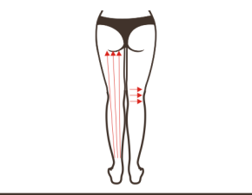  Technique6  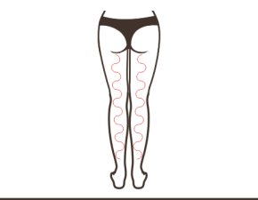  Technique12, 14, 20  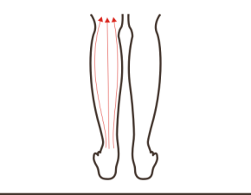  Technique13, 21  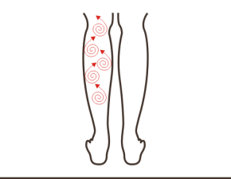  Technique15, 17, 23, 28  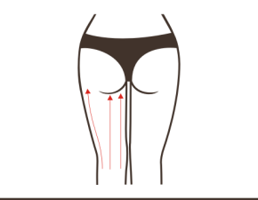  Technique16, 18, 24  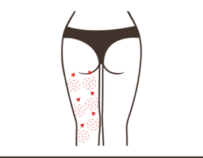  Technique25  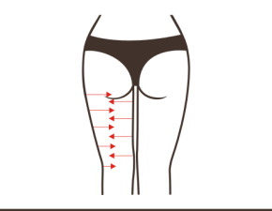  Technique26  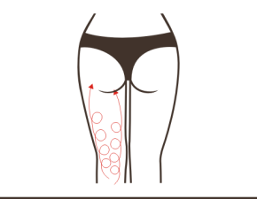  Technique29, 30, 31, 34, 36, 39, 40, 41, 46  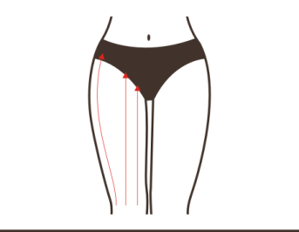  Technique35, 38, 44  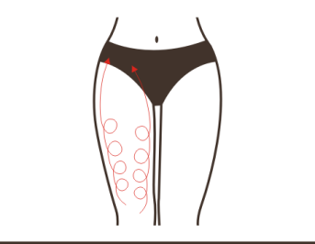  Technique37, 42  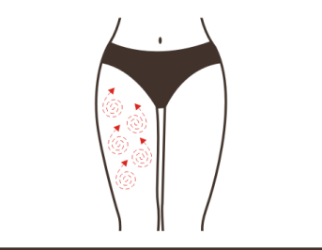  Technique43  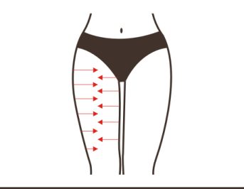
Treatment Suggestions
A course of treatment consists of ten treatment sessions. After one treatment, leg will be relaxed, and circulation will be accelerated. After one course of treatment, leg will become thin, there will be contraction of skin collagen due to heat effect, and tightening effect can obviously be felt on the skin. After 2 courses of treatment, there will be obvious results with the slimness and firmness of legs promoted. 3 courses will help consolidate the effects.

